; Official Publication of ALOA—An International Association of Security Professionals

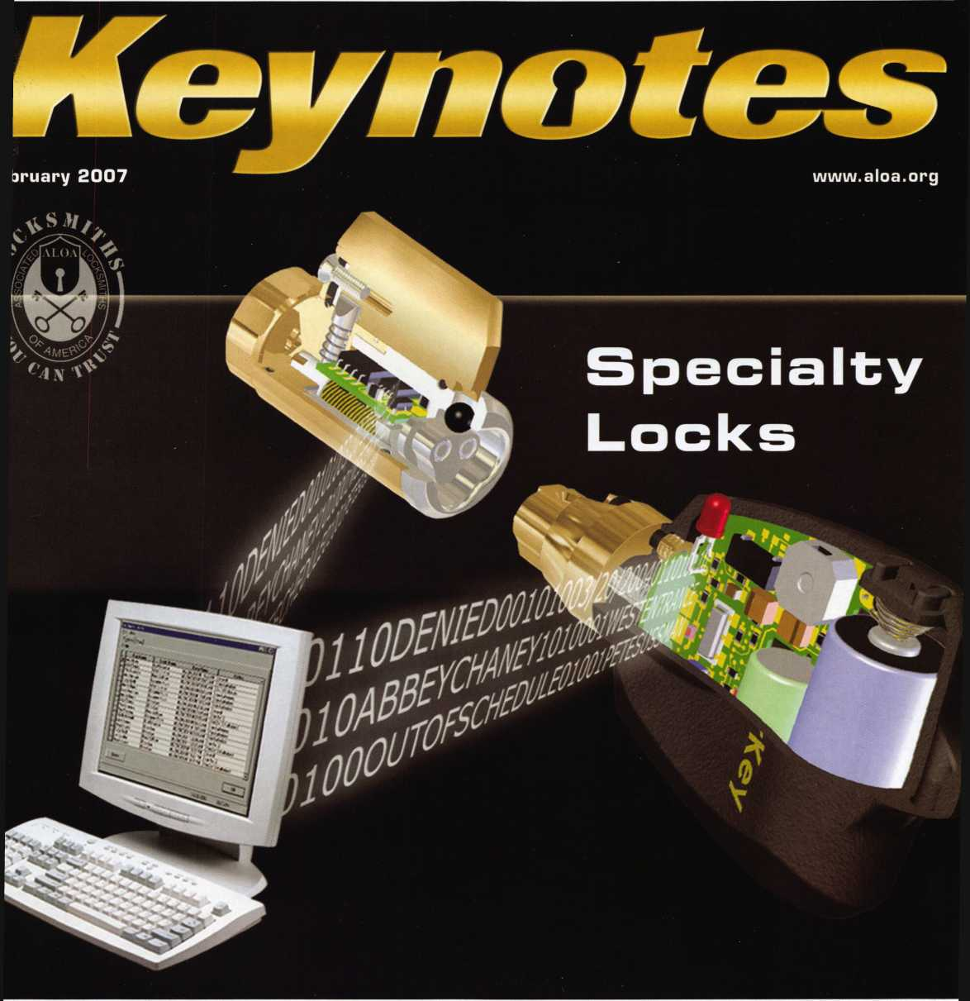

LUS!

reg Perry Was Not Born Yesterday

onflict Control, Listening,

oin to Start an RLOR Chapter and More!

* * * * * * * **\* # \*** % % $ % 3-DIGIT 303

BRECKH. CAMP CML POBCX 47070 ATLANTA GA 30362-0070

11111111111111111111111111111111111111111111111111111111111111

OUR STAND

**WE’RE IN BUSINESS TO HELP YOU**

**REDUCE DOWNTIME.**

Commercial vehicle insurance designed to help you get back on the road.

When your vehicle is out of business, so are commercial vehicle insurance as well as other you. That's why Allstate provides fast and fair insurance products designed to help keep your

claim service. Your local Allstate agent offers business in the race. Are you in Good Hands®?



1-888-322-3078

CALL NOW TO SPEAK TO AN

ALLSTATE AGENT NEAR YOU

**Instate**

JW ■ ; ... - : 1

|

**Subject to availability and qualifications. Allstate Insurance Company and Allstate Indemnity Company, Northbrook, 11. Allstate County Mutual Insurance Company, Irving, TX. Allstate New Jersey Insurance Company, Bridgewater. NJ. The "Cupped Hands" logo is a registered service mark and "Our Stand" is a service mark of Allstate Insurance Company. NASCAR11 is a registered trademark of the National Association for Stock Car Auto Racing, Inc. €> 2007 Allstate Insurance Company, Northbrook, TL.**

**ASTRA Ah«||**

**LOCKSMITHS NJ**

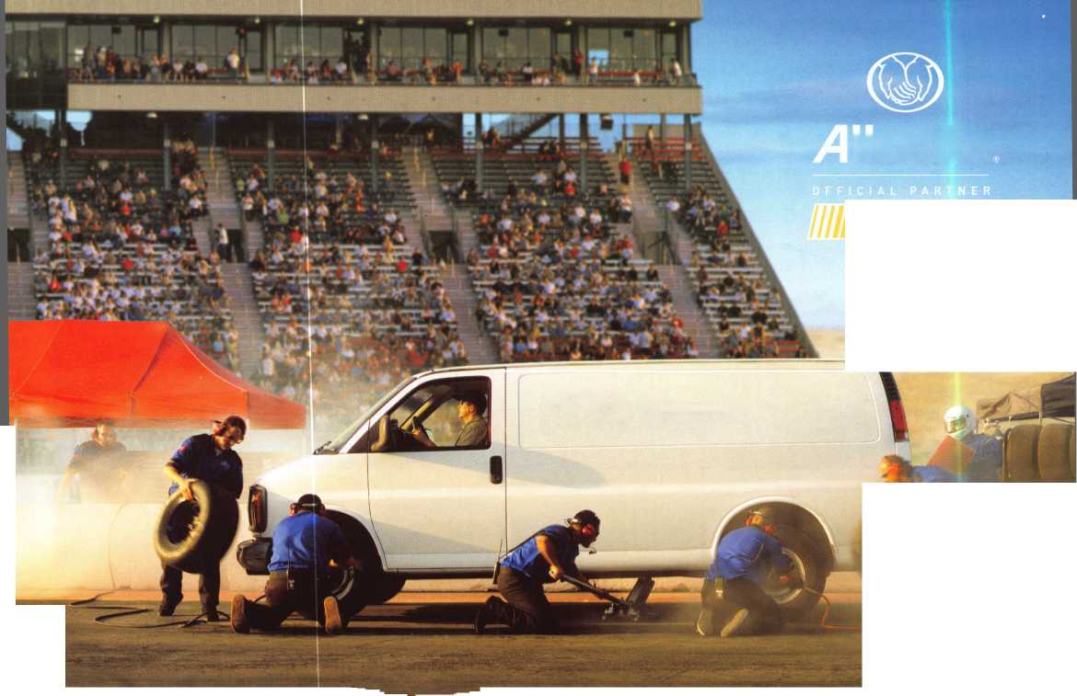

A Name You Know

As a business owner, you know the importance of a good name. Your name is your reputation. Your name stands for all that you offer in products and services. It’s a symbol of who you are. So, we thought you might like to know that Allstate, the name you know for insuring your personal vehicle and your home, also offers a business auto policy to help protect vehi­cles used in your locksmith business.

The following are coverages typically included in our business auto policy that might be important to you as a business owner:

Business Auto Liability coverage

* Higher limits up to $2,000,000 per occur­rence.
* Protects you if you are legally responsible for injuries and damages arising out of the ownership, maintenance, or use of business vehicles.
* Cost is based on several factors, includ­ing garage location, type and use of vehi­cle, and the violation and accident activi­ty of your drivers.
* Additional Insured coverage may be required when you contract with govern­mental agencies or bid on local commercial jobs.
* Generally not available on a personal auto policy.
* Usually is no charge to add an insured to a Commercial Auto policy.

Hired Auto coverage

* Provides liability coverage for those vehicles you rent, hire or borrow for business use.
* The premium for hired auto liability coverage is based on the estimated annual rental cost.
* Tools and Special Equipment
* Provides protection to permanently attached equipment on your vehicle.
* You will need to let your agent know the value of the equipment to include in the cost of the vehicle.

You’re good at your business. Your insurance com­pany should be the same way.

Contact an Allstate agent to discuss your business auto insurance needs. To be referred to an agent, please call 800.859.0247 or email [abisO@allstate.com](mailto:abisO@allstate.com).

Subject to availability and qualifications. Insurance coverage is subject to policy terms.

Allstate Insurance Company

Allstate Indemnity Company Northbrook, IL

Allstate County Mutual Insurance Company Irving, TX

Allstate New Jersey Insurance Company Bridgewater, NJ

allstate.com

© 2005 Allstate Insurance Company, Northbrook, IL

Get What's  
Coming To You

AIOA continues to provide you with this and other great benefits and services!



Need information in a hurry?

Use AlOA’s Fax On Demand service.

Just call 310-575-5027 and receive:

1. ALOA Index of Documents (1 pg)
2. Reasons to Join ALOA (2 pg)
3. Locksmith Career Summary (3 pgs)
4. Locksmith School List (1 pg)
5. ACE Class Schedule (1 pg)
6. Certification Information (5 pgs)
7. PRP Category List (1 pg)
8. ALOA Membership Application (1 pg)
9. ALOA List of Benefits (1 pg)
10. ASF Scholarship Application (1 pg)
11. ASF Scholarship Information (1 pg)
12. ALOA Video Library Order Form (1 pg)
13. Safe & Vault Technicians Association Membership

Application/Subscription Form (2 pgs)

1. Recertification Information (4 pgs)
2. Legislation Action Network Newsletter (2 pgs)
3. Various State Law Issues (8 pgs)
4. Industry Position Paper (1 pg)
5. ALOA Convention Class Schedule (3 pgs)
6. ALOA Convention Class Descriptions (30 pgs)
7. ALOA Convention Registration Forms (4 pgs)
8. Board of Directors Nomination Form (2 pgs)
9. ALOA Company Membership Application (2 pgs)

310**-**575-5027

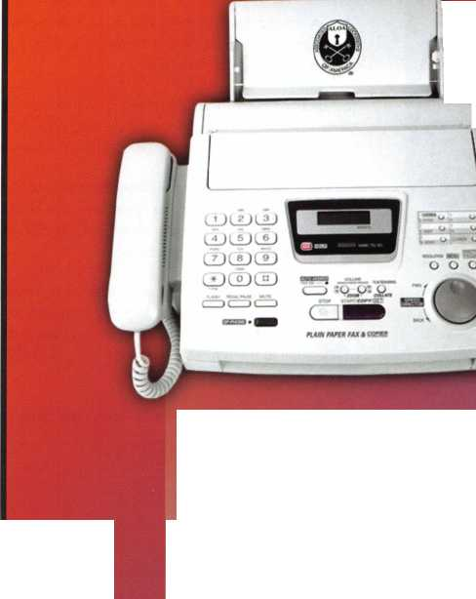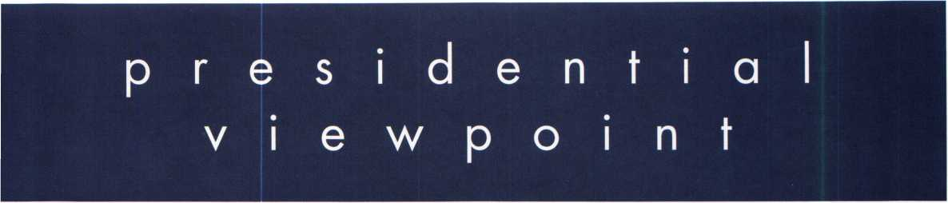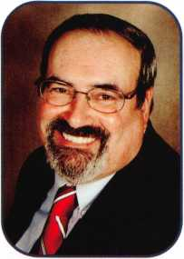

Dear Members,

With February, arrives another group of holidays which includes one of my favorites, Presidents' Day. It reminds me that it is time to submit our nominations. There are too many of us who sit on the sidelines loudly proclaiming,

"ALOA should do something about..." We forget that WE, the members, are ALOA. If you or someone you know have ideas that would benefit the membership; if you or someone you know would be an asset to the board, now is the time to step up to the plate.

You should have already received a nomination form in the mail. This is your opportunity to follow through with your ideas. This time we are not only electing regional directors for the southwest, northcentral, and southeast regions, but also for a new president. Don't sit on the bench another year. Participate in the process.

The eulogies delivered at President Ford's were truly inspirational. No matter the political affiliations, the same theme was reiterated throughout the speeches. Mr. Ford had not sought the office of vice-president nor the presidency, itself. But what was perfectly clear was that not only did he do what was asked of him, but did it with all the enthusi­asm of one who had sought the post.

Doing our job, doing it well, even when it is not of our own choosing is indeed to be admired. What a great char­acter trait! To perform one's duty is a standard not only to be exalted in a president, but in every citizen. As we pass through the time in our life's journey, we must not only "carpe diem", but must give some forethought on our obligations to the future. Did we do our job well? Have we enjoyed the journey? Will we have left things better, not worse?

A job well done! I hope we can learn from other people's life stories and answer all the above questions, yes. Take 'er easy!

Sincerely,



Robert E. Mock

Keynotes • February 2007

DEALERS & DISTRIBUTORS

REQUIRED

NINKAS

Call Today For Available Territories

(877) 913-7233

[www.inkas](http://www.inkas). ca

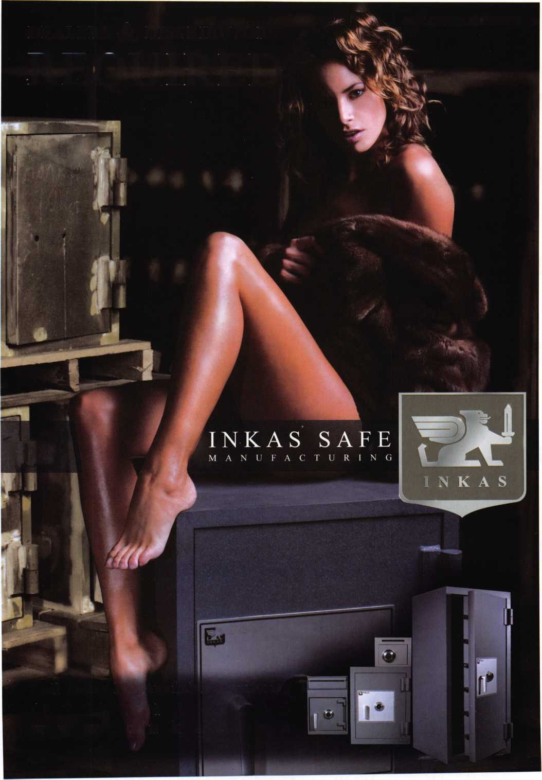

f

e

a

t

u

**res**

SPECIALTY LOCKS 2007

10

Cyberlock

Videx offers four different levels for managing the CyberLock sytem. Read what they are.

**14**

Member Spotlight:

Carl M. Braun - Star Lock & Key Co. Inc.

Find out more about this 80+ year locksmith business and how they have survived through Hurricane Katrina.

**18**

Conflict Control

Read on to find out how to keep conflict to a minimum through managment techniques and understanding.

by Patti Fralix

22

This Safe Designer Wasn't Born Yesterday

What do Greg Perry, 3 cops, a pastor and several church members have in common? Find out!

by Greg Perry, CML, CPS

**28**

Listen To Your Customers

Claire Cohen not only shows you how you can become a better listener to your customer but a more effective saleperson as well.

by Claire Cohen, CML

**42**

Rejuvenate, Recharge and Reconnect!

Is your local ALOA Chapter or affiliate taking advantage of all the benefits available to you? Find out how you can help.

|  |  |  |
| --- | --- | --- |
| r |  |  |
| AD INDEX | |  |
| Allstate | ..Inside Front Cover |  |
| Fax on Demand | 1 |  |
| INKAS | 3 |  |
| ALOA 2007 | 7 |  |
| Internet Ads | 13 |  |
| Ben Jim | 17 |  |
| Safetech 2007 | 19 |  |
| ALOA Cruise Winner | 21 |  |
| Clearstar | 21 |  |
| Turn 10 | 23 |  |
| DKS | 25 |  |
| ALOA Golf Tournament | 27 |  |
| Scwab | 29 |  |
| ALOA Member Recruitment. | 31 |  |
| PBP | 32 |  |
| Ultralift | 33 |  |
| A&B | 40 |  |
| Locksmithing UNL | 40 |  |
| Coast Safe & Lock | 40 |  |
| HL Flake | 41 |  |
| Jet Hardware | 44 |  |
| Door Jam Armor | ..Inside Back Cover |  |
| CCL | Back Cover |  |
|  |  |  |

**Departments**

|  |  |  |  |  |  |  |  |
| --- | --- | --- | --- | --- | --- | --- | --- |
| Presidential | Executive | 5 | Calendar | 8 | Classified | 34 | Legislative 38 |
| Viewpoint 2 | Applicants .... | 6 | Core | 9 | Associate Members | 36 |
|  |

Visit our NEW website

at [www.aloa.org](http://www.aloa.org)

executive



C4 N

Volume 53, Issue 2

Additional contact information for the ALOA Board is available on the ALOA website—  
[www.aloa.org](http://www.aloa.org) or by contacting the ALOA office at 3500 Easy Street; Dallas, TX 75247;  
(800)532-2562; FAX (214)819-9736; e-mail [aloa@aloa.org](mailto:aloa@aloa.org).

Editor & Director of Creative Services Comptroller

|  |  |  |  |
| --- | --- | --- | --- |
| Betty Southerland | [betty@aloa.org](mailto:betty@aloa.org) | Kathy Romo | [kathy@aloa.org](mailto:kathy@aloa.org) |
| Advertising Sales |  | Membership Development Manager | |
| Kim Hammond | voice: 817-645-6778 | Ellen R. McEwen | [ellen@aloa.org](mailto:ellen@aloa.org) |
|  | Fax: 817-645-7599 |  |
|  | e-mail: [adsales@aloa.org](mailto:adsales@aloa.org) | Membership Coordinator | Shelly Jett |
| Executive Director |  | Convention & Meetings Assistant Karen Lyons | |
| Charles W. Gibson, Jr., CAE | [charlie@aloa.org](mailto:charlie@aloa.org) |  |  |
|  | PRP/Education Coordinator Shelley Melton | |
| Associate Executive Director | |  |  |
| David Lowell, CML, CMST .... | [david@aloa.org](mailto:david@aloa.org) | Mail Room Coordinator | Kevin Wesley |
| Convention & Meetings Manager | | Graphic Designer | Margarita Garza |
| Jo Anne Mims | [joanne@aloa.org](mailto:joanne@aloa.org) | Accounting Coordinator | Joyce Nixon |
| Operations/Membership Manager | | Executive Assistant |  |
| Mary May | [mary@aloa.org](mailto:mary@aloa.org) | Sue Langford |
| Director of IT Operations |  | Assistant Education Manager Bob Stafford, CML | |
| Greg K. Jackson | [greg@aloa.org](mailto:greg@aloa.org) | Legislative Manager |  |
| Tim McMullen |
| Contributors |  |  |  |
| Jerome Andrews, CML | Ray D'Adamo, CML | Randy Simpson, CML, CPP | Tom Seroogy |
| Paul Chandler, CRL | Billy Edwards, CML | Robert Stafford, CML | Charles Stephenson, CPS |
| Claire Cohen, CML | Dan Graffeo, CRL,CMST | Dave Thielen, CML | Dennis Watanabe, CML, CMST |
| Brian Costley, CML, CMST | Jim Hancock, CPL | Greg Perry, CML,CPS |  |
| Eric Costley, CRL | Jeff Nunberg, CML, CMST |  |  |

Mission Statement: The Associated Locksmiths of America, Inc. is dedicated to enhancing the professionalism, education and ethics among locksmiths and those in related sectors of the physical security industry. With approximately 10,000 members in the United States, Canada and the freeworld, ALOA is poised to help members obtain the knowledge, the strength, and the confidence to perform their role in the physical security field with pride and dignity. But it is only through active involvement and participation that ALOA can fully achieve its potential—and can help members to achieve theirs.

Policies: Keynotes® is the official publication of the Associated Locksmiths of America, Inc. (ALOA). Keynotes® acts as a moderator without approving, disapproving, or guaranteeing the validity or accuracy of any data, claim, or opinion appearing under a byline or obtained or quoted from an acknowl­edged source. The opinions expressed by the authors do not necessarily reflect the official views of ALOA. Also, appearance of advertisements and new products or service information does not constitute an endorsement of products or services featured by the Association. The Association does not accept responsibility for the inaccuracy of any data, claim, or opinion appearing in this publication, due to typographical errors on the part of the authors, Association staff or its agents.

Editor's Note: This publication is designed to provide accurate and authoritative information in regard to the subject matter covered. It is provided and disseminated with the understanding that the publisher is not engaged in rendering legal or other professional services. If legal advice and other expert assistance is required, the services of a competent professional should be sought.

Authors7 Payment: Payment for eligible submissions to Keynotes will be based on the following criteria: topic, time spent and past contributions. Authors who regularly submit to Keynotes® are generally paid a higher rate. The latter is especially true of authors who write to fit specific editorial needs and submit said copy by Keynotes® deadlines. As a general guideline: Average payment for a 750 word, business or 'light' technical article would be $200. Payment for a 1500 word article involving significantly higher time and research efforts would be $400.

Payment will not be offered for articles submitted by ALOA employees or members of the ALOA Board of Directors (unless material is of a technical nature), nor for articles submitted by a company that promote that company's products or services. ALOA reserves the right not to pay for articles sub­mitted by an individual(s) that promote a particular company's products or services.

Disclaimer: The Associated Locksmiths of America, Inc., (ALOA), reserves the right to refuse any article for any reason. Additionally, ALOA reserves the right to edit, amend or modify any article submitted for publication in order to preserve technical accuracy, clarity, fairness or grammatical correct­ness. ALOA will make the best efforts to notify the author of any changes. The extent of ALOA's liability for any article or information contained there­in will be a notice of correction or retraction in the next possible issue.

Keynotes® (ISSN 0277 0792) is published monthly except for the combined June/July issue by The Associated Locksmiths of America, Inc., 3500 Easy St., Dallas, TX 75247-6416. Telephone: (214) 819-9733; FAX (214) 819-9736; e-mail [aloa@aloa.org](mailto:aloa@aloa.org). Subscription rates for members-$15.00 per year. Periodical class postage paid at Dallas, Texas. POSTMASTER: Send address changes to: Keynotes, 3500 Easy St., Dallas, TX 75247-6416. © Copyright 2003, All rights reserved. No part of the contents may be reproduced or reprinted in any form without prior written permission of the publisher.

President

Robert Mock  
(856) 863-0710  
president@aloa. org

Secretary

John Soderland, CML, CMST  
(414) 327-5625  
secreta ry@a loa. org

Directors, Northeast

Tom Foxwell  
(410) 206-5772  
[nedirector@aloa.org](mailto:nedirector@aloa.org)

Robert D. DeWeese, CML, CPS  
(410) 285-0101  
ned i rector@a loa. org

Directors, Southeast

Tom Gillingham, Jr., CML, CPS  
(615) 264-0747  
sed i rector@a loa. org

Ken Kupferman, CML, CPS  
(813) 232-7600  
sed i rector@a loa. org

Director, North Central

William Smith, RL (920) 893-5282 Guy Spinello, RL (815) 394-1000 [ncdirector@aloa.org](mailto:ncdirector@aloa.org)

Director, South Central

CD Lipscomb, CML, CPS  
(903) 874-3522  
sed i rector@a loa. org

Directors, Southwest

Greg Parks, CRL  
(858) 271-1155  
s wd i rector@a!oa. org

Julie McCluney, CRL  
(714) 636-5652  
swd i rector@aloa. org

Director, Northwest

Keith E. Whiting, CML, CFL  
(360) 601-5656  
nwd i rector@a loa. org

Director, European

Hans Mejlshede, CML  
(453) 539-3939  
eu rd i rector@a loa. org

Director, Associate

Dan Floeck  
(800)231-4105  
[asdirector@aloa.org](mailto:asdirector@aloa.org)

Trustees

[trustees@aloa.org](mailto:trustees@aloa.org)

Randy Simpson, CML, CPP  
(281) 240-5959

John J. Greenan, CML, CPS  
(773) 486.2030

William Young, CML, CPS  
(610) 647-5042

Past Presidents

2003-2005 William Young, CML, CPS  
2001-2003 Randy Simpson, CML  
1999-2001 John Greenan, CML, CPS  
1997-1999 Dallas C. Brooks  
1995-1997 David Lowell, CML, CMST  
1993-1995 Breck Camp, CML  
1991-1993 Henry Printz, CML  
1989-1991 Evelyn Wersonick, CML, CPS  
1987-1989 Leonard Passarello, CPL  
1985-1987 Joe Jackman, CML  
1983-1985 Stanley Haney, CPL  
1981-1983 Louis LaGreco, CPL  
1979-1981 John Kerr, RL  
1977-1979 Clifford Cox, CML  
1974-1977 Charles Hetherington  
1972-1974 Gene Laughridge  
1970-1972 William Dutcher, RL  
1968-1970 Constant Maffey, RL  
1966-1968 Harold Edelstein, RL  
1964-1966 William Meacham  
1962-1964 Robert Rackliffe, CPL  
1960-1962 Edwin Toepfer, RL  
1956-1960 Ernest Johannesen

\

Keynotes • February 2007

**5**

**CA**

**Ml**

applicants

for membership

Irvine

Avraham Cohen

**FL**

**Naples**

Leslie Gross



Calumet City

Patrick J. Giglio

**MA**

Winchendon

Keith Swenson

**MD**

Baltimore

Glenwood B. Oats Sr

Sponsor: Philip A. Rovenolt CPL **Boyds**

Joe Geraci

Sponsor: Robert C. Muhlboch **Nottingham**

James Langlinais

Grand Blanc

Randy A. Montpas

Sponsor: Marc A. Dearing CRL

**MN**

Shakopee

Michael Sessions

Sponsor: Richard C. Sievers

**MO**

Saint Louis

Michelle A. Fogerty

**NJ**

Paramus

Donald L Newhouse

Sponsor: Nicholas M. Hart CPL

**PA**

Johnstown

Gregory J. Borow RL Raymond P. Kauffman RL

Tarentum

Thomas J. Parker Jr

**TN**

Erin

Jay Reedy

**TX**

Austin

Dave Dyess

Sponsor: Dan W. Dyess **Dallas**

Ben J. Parker RL

Sponsor: Peter A. Thorne

Wl

Kenosha

Robert B. Roush

Sponsor: Christopher C. Olson CRL

Milwaukee

Nicholas L. Bauer RL

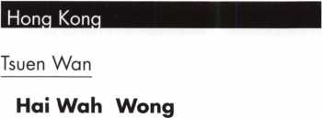

Tsuen Wan N.T.

YiuWah Chek

Sponsor: Kwok-kei Leung

These applicants are scheduled for clearance as members of ALOA. The names are published for member review and comment within 30 days of this Keynotes issue date, respectively, to ensure , ' A °PP',CantS ^ standar^ 0fALOAs Code of Ethics Protests, if any, should be addressed to the Membership Department and must be signed. Active Membership applicants (a) have worked in e industry two or more years. Allied Membership (AL) applicants are not locksmiths, but work in a security-related field. Apprentice Membership (AP) applicants have worked in the industry less than two years

**6**

Keynotes • February 2007



Start Your Engines!

This year, with a great location and a  
schedule chock-full of exciting classes  
and events, we are pulling out all the  
stops to celebrate the ALOA Convention  
and Security Expo in Charlotte, North  
Carolina.

Having built an international reputation  
among locksmiths as a powerful resource  
to explore industry innovation and form  
industry alliances, ALOA 2007 is the ideal  
place to learn, network or to showcase  
your security-related business on the  
show floor.

This year weve thought of everything  
from an exciting location to a comfort-  
able hotel and a convention center that is  
equipped to handle your every need. The  
exhibit hall promises to be overflowing  
with the latest technology and new mer-  
chandise.

july 22-29, 2007 charlotte, north Carolina

|  |  |
| --- | --- |
| 1 LA/ |  |
| N 4 5  3  KlOOOr/min | e' 1 |
| **2 | \ |
|  | 7|  | |
| '0 a,_oa 3007 | qJ |

aloa convention and security expo

*51st ANNUAL*

Dont miss out!

800-532-2562

upcoming events

2/3 Holiday Inn Select • Tulsa, Oklahoma 2/7

2007 Annual Distributor's Show, 9am-4pm  
Oklahoma Master Locksmith Association 2/10  
Contact: Harry Sher, CML  
479-471-8890 • [hsher@starband.net](mailto:hsher@starband.net)

TBA • Franklin, Ohio Ohio Valley Chapter Meeting Renaissance Charlotte Suites Hotel Charlotte, NC • NC Locksmith's Assc. Regional Trade Show • [www.ncla.us](http://www.ncla.us)

2/14 TLA Convention • Houston, Texas. [www.texaslocksmiths.org](http://www.texaslocksmiths.org)

3/7 TBA • Franklin, Ohio

Ohio Valley Chapter Meeting

3/31-4/5 Safetech 2007 • Lexington, KY

Safe & Vault Technicians Association [www.savta.org](http://www.savta.org)

3/28-30 ISC West Expo • Las Vegas, NV Sands Expo & Convention Center (800) 840-5602

4/4 Hometown Buffet • Franklin, Ohio

Ohio Valley Chapter Meeting Contact: Chairman Terry McClain, CRL 513-464-8806

5/18-20 ELF Convention 2007 • Riga, Latvia European Locksmith Federation Exhibition - Social events -Education [www.elf2007.com](http://www.elf2007.com) • [ruta.reinika@prplus.lv](mailto:ruta.reinika@prplus.lv)

UPCOMING ACE CLASSES

February 9-10, 2007 February 10, 2007 March 8-9, 2007

March 15-16, 2007 March 28 - 30, 2007

April 14-15, 2007 April 21, 2007 April 26 - 28, 2007

May 7- 12, 2007

May 17-19, 2007

Welch, MN • Minnesota Chapter of ALOA For specific course schedule please contact:

Dana Lee, CML • 612-722-9181

Detroit, Ml • Locksmiths Security Association

Life Safety Codes w/L-07 PRP

Contact: Robert C. Noble, CML • 810-385-9329

Lexington, KY • SAFETECH 2007

For specific course schedule please contact:

ALOA Education • [education@aloa.org](mailto:education@aloa.org)

800-532-2562x104

Northbrook, IL • Clark Security Products

For specific course schedule please contact:

Joan Emrick • 858-974-6737

Vancouver, British Columbia • British Columbia

Association of Security Professionals

Bill Beazley • 14 ALOA Certified Classes

[lockpicker@helmz.com](mailto:lockpicker@helmz.com) • 604-291-0444

Kansas City, MO • Missouri-Kansas Locksmith Assc.

For specific course schedule please contact:

Bob Turner • 816-525-5522

Kearney, NE • Nebraska Chapter of ALOA

Push Button Mechanical Lock Manipulation

Elmer Howard • [safeman@cox.net](mailto:safeman@cox.net) • 402-676-8973

Denver, Colorado • Central & Southern Colorado

Locksmths Association • 9 ALOA Certified Classes

Contact: Barry Meyers, CPL • 303-688-1404

Dallas, Texas • ALOA Training Center

Six-Day Basic Locksmithing Course

ALOA Education • [education@aloa.org](mailto:education@aloa.org)

800-532-2562x104

Dallas, Texas • ALOA Training Center

3-Day Automotive Locksmith Course

ALOA Education • [education@aloa.org](mailto:education@aloa.org)

800-532-2562x104

UPCOMING PRP Sittings

2/11/07 Sunday 8:00am • Welch, MN • Dana Lee, CML

Minnesota Chapter of ALOA • 952-887-1199 2/17/07 Saturday 8:00am • Houston, TX • ALOA Certification

Texas Locksmiths Association • 800-532-2562x104 3/10/07 Saturday 8:00am • Lexington, KY • ALOA Certification

SAFETECH2007 • [education@aloa.org](mailto:education@aloa.org) • 800-532-2562x104 3/18/07 Sunday 8:00am • Northbrook, IL • Joan Emrick

Clark Security Products • 858-974-6737 3/25/07 Sunday 8:00am • Novi, Ml • Bonnie Weston

IDN Hardware Sales* 313-591-1150

3/31/07 Saturday 8:00am • Vancouver, BC • ALOA Certification

British Columbia Association of Security Professionals [education@aloa.org](mailto:education@aloa.org) • 800-532-2562x104 4/28/07 Saturday 8:00am • Roseville, Ml • Robert C. Noble, CML

Locksmith Security Association • 810-385-9329 4/28/07 Saturday 6:00pm • Denver, CO • Barry Meyer, CPL

Central & Southern Colorado Locksmiths Association 303-688-4104 • [acomal@gwest.net](mailto:acomal@gwest.net)

5/12/07 Saturday 1:00pm • Dallas, TX • ALOA Certification

ALOA Training Center • [education@aloa.org](mailto:education@aloa.org) • 800-532-2562x104

**Contact the ALOA Education Department for a list  
of classes and training offered in-house.**

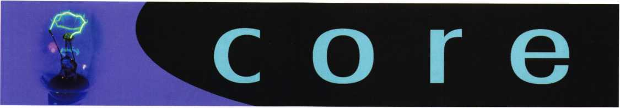

Phony Locksmiths in the News

cbsl 1 tv.com/topstories/local_story_025235906. html

[www.nbcl](http://www.nbcl) 0.com/video/10715012/detail.html

On the Road with the ALOA Board of Directors

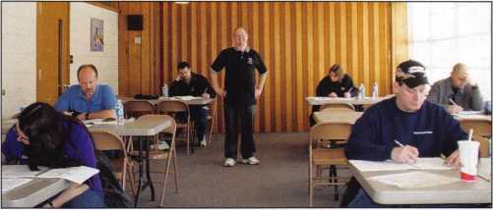

Board Secretary Soderland was the proctor at a recent regional PRP sitting near Milwaukee, Wisconsin.

North Central Director Bill Smith was also on hand to lend his assistance.

Secretary Soderland  
recently presented  
North Central Director  
Bill Smith with a  
Wisconsin Indianhead  
Chapter Award in  
recognition of loyalty  
and support to the  
chapter during 2006.

ASSA Launches Intelligent Lock Stand-Alone System

ASSA recently announced its release of a new intelligent stand alone lock system.

"This breakthrough technology combines the best of design and electronics in the smartest possible manner," says Jim Slusser, Security Manager for the Maryland Stadium Authority.

Named CLIQ, this new technology gives control over all keys which can easily be upgraded and tailor-made to suit any needs. Since every key has its own identity, it becomes the "personal property" of the key holder. CLIQ cylinders and keys keep an independent audit trail of access.

"Every time you insert the key into the cylinder, it records the unique key number, date and time giv­ing an unparalleled audit trail for movement inside a correctional facility," says Tom Demont, Director of Sales & Marketing for ASSA. CLIQ makes intelligent, flexible and high security lock systems possible.

The key's mechanical design creates the founda­tion made up of different security zones in the same way as in mechanical lock systems. The electronic programming of the keys gives authori­zation to individuals or to group of individuals. CLIQ technology's basic idea is the creation of an intelligent security system. That means a lock sys­tem that retains a high level of security despite upgrading, alterations or expansion. Even after many years of use by a continual flow of new employees or changes occurring in the facility, the level of security will remain the same.

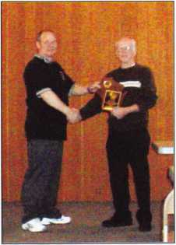

**Electronic Locks that Cannot Be Comoromised**

ID

Keynotes • February 2007

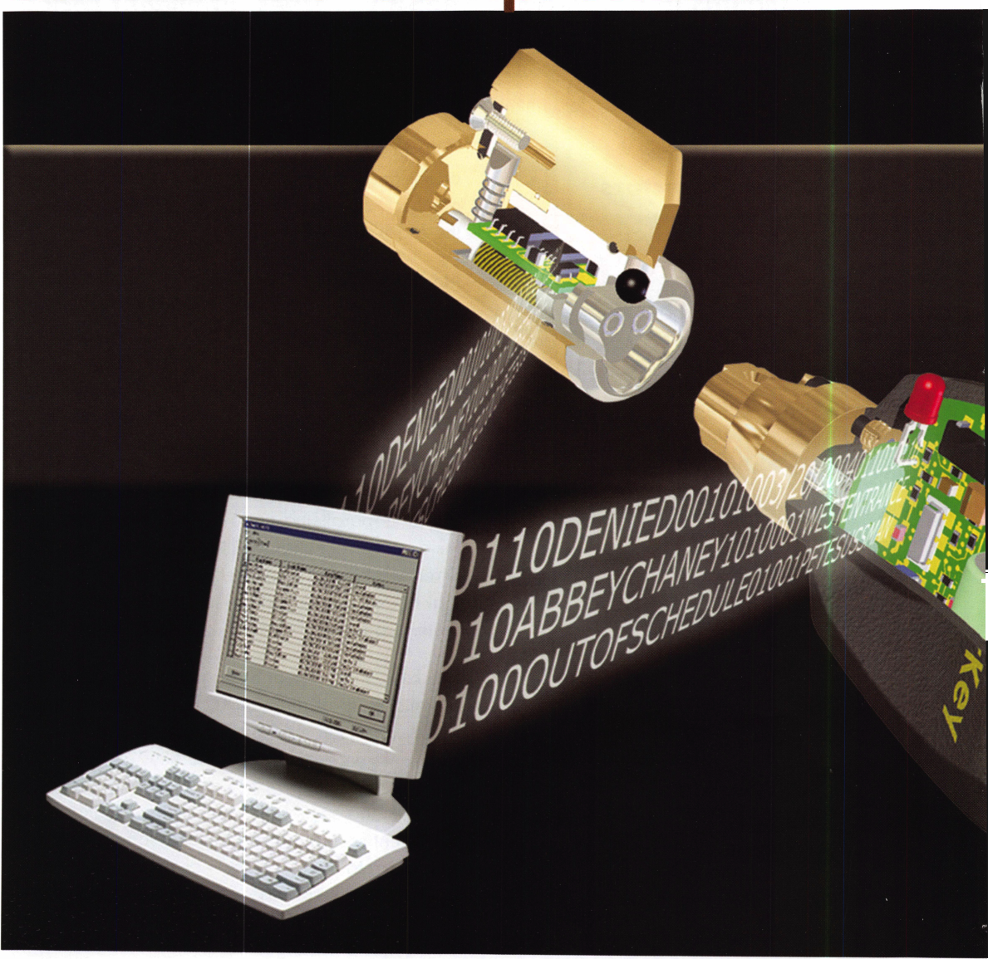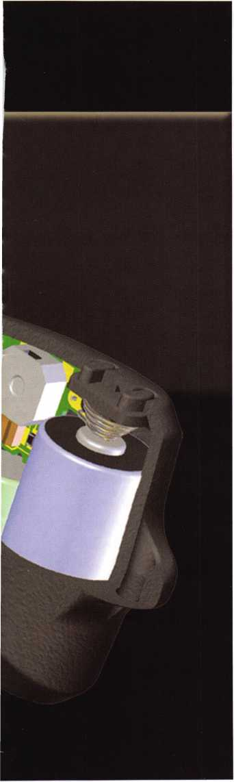

CyberLock* cylinders quickly convert exist-  
ing mechanical lock hardware to a high-  
security lock simply by replacing the  
mechanical lock cylinder with the new elec-  
tronic cylinder. Each CyberLock cylinder

contains a microprocessor and  
memory and is designed to the  
exact dimensional standards of

the mechanical cylinder it is  
replacing. The system consists of  
the CyberLock cylinder that can-  
not be picked and the CyberKey  
that cannot be duplicated.

The CyberLock family includes  
intelligent padlocks and a full  
line of electronic cylinders that  
install in doors and cabinets  
without any need for hardwiring  
or structural changes. Access  
privileges and battery power are  
located in the key. Each key con-  
tains permissions on what locks  
the key can open, with a schedule  
of days and times it will open  
those locks. Each time the key  
opens a lock, a record is stored in  
both the key and the lock cylin-  
der, creating a concise audit  
report of events.

Videx offers four different levels  
for managing the CyberLock sys-  
tem. For companies that need  
high-security locks and keys with  
locks that cannot be picked and  
keys that cannot be duplicated,

EntryPoint is a hardware-only system that requires no programming software. CyberAudit-Web Lite adds the ability to set access schedules and view an audit trail just by logging on to a Videx-hosted web site.

For companies that need a high level of security and key control, CyberAudit 2.0 is a Windows program that includes access scheduling and audit reports, along with fea­tures such as key expirations, report genera­tion, and email notification of events. For large geographically widespread companies, feature-rich CyberAudit-Web Enterprise is packaged on a Linux-based server and accessed by using a web browser on a local network or the internet.

CyberLock is an innovative lock system that easily converts existing mechanical locks into an access control system. With elec­tronic lock cylinders and programmable keys, you can create a powerful system to track and control access to every lock.

How does it work?

CyberLock electronic cylinders replace stan­dard mechanical cylinders.

Each CyberLock cylinder is an electronic version of a standard mechanical lock cylin­der. Installing the cylinder into the lock hardware is as simple as removing the exist­ing mechanical cylinder.

Keynotes • February 2007

nic cylinders without pins and keyways

ly cannot be picked or compromised using  
bumping techniques

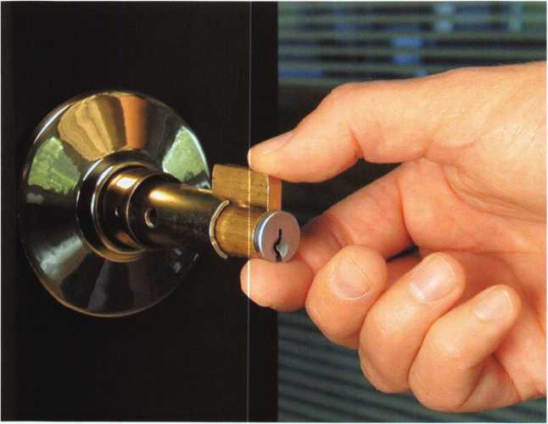

Step One: Remove Core

No wiring or battery is required at the lock.

The lock installs without wiring of any kind, and does not contain a battery. The power required to open a lock comes from the bat­tery in the key. CyberKeys use a 3-volt lithi­um battery, easily replaceable in the field (#3_CyberKey Photo #3).

CyberLocks cannot be picked.

CyberLocks have no keyway, and cannot be picked like a mechanical lock. CyberLocks resist forced rotation, and are designed to remain in the locked position if tampered with.

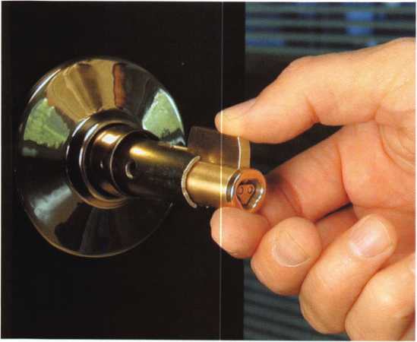

Step Two: Insert CLK Core

CyberKeys® cannot be duplicated.

It’s not possible to create a duplicate of a CyberKey. Passwords in the software and hardware are unique to each installation, and protect against creation of unautho­rized keys. And, although two keys in the system can be programmed alike, each one will make its own unique record of events in the software (#4_Audit Trail Photo).

Additional Information on CyberLock

The CyberLock family includes intelligent padlocks and a full line of over 200 different electronic cylinders that install in doors and cabinets. Each key contains permis­sions on what locks the key can open, with a schedule of days and times it will open those locks. Each time the key opens a lock, a record is stored in both the key and the lock cylinder, creating a concise audit report of events.

**2**

Keynotes • February 2007

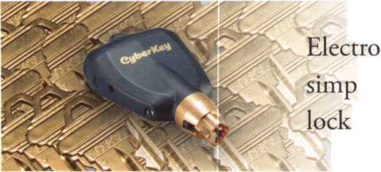

Four ways to manage the CyberLock system

Videx offers four different levels of management for the CyberLock system: EntryPoint, CyberAudit-Web Lite, CyberAudit 2.0, and CAW Enterprise. This range of man­agement tools is designed to accommodate every type of installation, from the homeowner to small businesses to large corporations or campus settings.

Andy Hilverda, Vice President of Videx, Inc., emphasizes the security of electronic lock systems; “Electronic locks offer many advantages over mechanical lock-based systems. Electronic cylinders without pins and keyways simply can­not be picked or compromised using lock bumping tech­niques, so prevalent in the news today. In addition,

CyberLock adds scheduled access and an audit trail of all  
activities. This makes it a very effective security solution  
for many different customers. CyberLock customers

include high-profile  
installations such as  
Sydney

Opera House, the AuditTrai|

Dutch Parliament,

and thousands of cell towers across the United States, as  
well as countless schools, churches, water facilities,  
and municipalities.”

|  |  |  |  |  |
| --- | --- | --- | --- | --- |
| ► Joe Wilson | East Entrance | Date/Time  03/20/2OT6 06:14:22 AM | Status ! -  Denied | |
| Abty Chaney | West Entrance | 03/20/2006 07:28:03 AM | Key Authorized |  |
| Pete Sussman | Records Room | 03/20/2006 07:59:15 AM | Out of Schedule | |
| m John Michaels | Computer Room | 03/20/2006 0&00:03 AM | Kery Authorized | |
| ; Evefcm Leflei | West Entrance | 03/20/2006 08:12:16 AM | Key Authorized | |
| ■: Juanita Banks | Computer Room | 03/20/2006 0618:52 AM | Key Authorized | |
| Andy Ounsmote | Computer Room | 03/20/2006 08:27:12 AM | Denied | |

ALOA.ORG: Your Digital Sales  
Partner

Isn’t it time you placed your ad on the ALOA website?  
ALOA.ORG and findalocksmith.com receive millions of  
“hits” per year. Let us put your business in front of  
thousands of potential clients.

Website Advertising: Receive an animated banner ad on our main  
page that links to your full-page, 4-color ad!

Zip-Code Banner Ad: Want to stand out in a sea of ALOA Members on findalocksmith.com?

Purchase banner advertising specific to your geographical area!

Discounted ad rates are available for members, exhibitors, sponsors and current advertisers.

Call for a quote today! Ask for the Advertising Sales Department at 1-800-532-2562. We’re waiting to talk to you!



Keynotes • February 2007

**MEMBER\***

potlight

Welcome to our new monthly feature! Each month we will highlight a current ALOA mem­ber & their lockshop with a short bio and in-depth questions. To be considered or to recom­mend a fellow ALOA member please read the information provided at the end of this article.

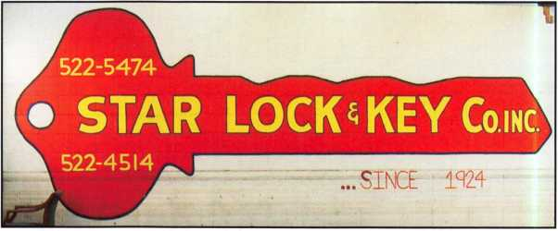

Carl M. Braun, owner of Star Lock & Key Co. Inc., pro­vides complete lock service to the New Orleans area. They have been a part of the locksmith business for over 80 years. Established in 1924 by Carls father and uncle, Star Lock & Key Co. Inc. has gone through 3 generations of the Braun family. They have also endured one of their biggest and most devastating challenges to date, Hurricane Katrina.

Star Lock & Key Co. Inc.

200 North Galvez Street 504-522-5474

New Orleans, Louisiana 70119

1. Tell us about your background in security and  
   your experience in locksmithing.

Carl My father, Carl Sr., and his brother, Daniel,  
started in this business from scratch in 1924. Our  
family has grown up with this business all of our  
life and now I have my 2 sons with me running it.

1. How long have you had your lock shop open?

Carl: The shop has been open since 1924.

1. How many employees  
   do you have?

Carl: We currently  
employ 6 employees  
including myself.

Carl Braun - 23 years  
Chad Braun - 13 years  
Ryan Braun - 6 years  
Norman Levy - 32 years  
Bert Newman - 24 years  
Larry Warren - 8 years

Kevin Jones - 13 years (sorry to say that he recently passed on)  
Marion Braun - Worked in the shop until she turned 84

1. Name one thing in your lockshop that says the most about you.

Carl: Our lockshop is very clean and very organized.

1. How did you get involved in the business? i.e. starting point?

Carl: I got started in the business when my father took sick. He had told me that he would love for me to run the business and keep it in the family, so I did. We now have 3 generations here at the shop. I also have 6 grand­children that hopefully one day will take interest in it also.

1. What are the changes that youfve noticed in the security technology recently?

Carl: I have noticed that more and more people are going to electronic access and restrictive keyways.

1. What do you see as the future of security?

Carl: Electronic restricted access and audit trails.

1. How do you stay informed about new products  
   and security techniques? i.e. magazines, conventions,  
   classes, etc.

Carl We recieve magazines to read whats new and  
upcoming. Also, we visit the ALOA conventions to  
learn whats new on the market.

1. In the Katrina aftermath...what kind of lock-  
   smithing issues were you dealing with? If any.

Carl Most places around the city had gotten water  
above the locks so we were dealing with locks that  
wouldn’t open with the customer’s key because the  
cylinders, not to mention the whole lock had become  
rusted from all the saltwater. In addition to helping our  
customers that had came back to the area after the  
storm, we also had to rebuild our business which need-  
less to say had 2 weeks worth of sitting water in it, 4  
feet deep. We actually had to use two water lines: One  
at 5.5ft when the water was running through and one at  
4ft where it sat.

1. In what  
   way has your  
   lockshop busi-  
   ness been  
   affected by dev-  
   astation left by  
   hurricane  
   Katrina? More  
   or less.

Carl: We have  
lost 75% of our

walk-in business. Our outside business has increased,  
but the jobs are taking longer to complete due to the  
amount of work involved in the job.

1. How has life changed for you as a locksmith in  
   the past year?

Carl: As being an owner of the business I had to watch  
the spending, making sure I could keep the business  
running.

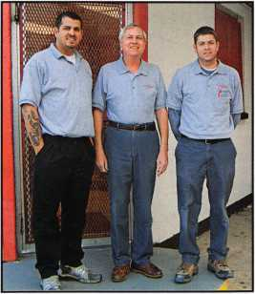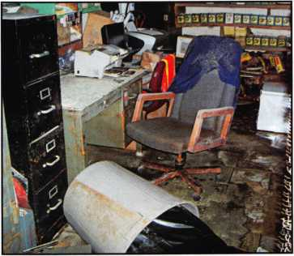

Keynotes • February 2007

**15**

1. Do you find that other locksmiths in the New Orleans area work together on referrals and workflow?

Carl: Yes. All locksmiths in this area have a great relationship. Of course there are a few exceptions.

1. Do you feel that locksmiths have gotten a bad rap recently in the news?

Carl: No not recently. In the past I would say yes, but not since they are making all of us in the security profession become licensed.

1. Give us your biggest locksmithing horror story,

toughest job, or the job

that taught you the biggest lesson.

Carl: My biggest lesson that I  
have learned in this business is  
that there is no reason to be  
in a rush for anything.

Patience is a virtue.

1. What advice can you  
   give to an aspiring security  
   professional?

Carl: Be able to think on  
your feet. The stuff we do in  
this profession mostly cant be  
learned in a classroom. The  
best way to learn in on the job  
with a good teacher.

1. Can you remember your  
   first big security job? What  
   can you tell us about it?

Carl: My first big job was rekeying a college campus.  
The toughest part of the job was the customer figur-  
ing out how they wanted to key the campus up. As  
we all know there were some people who had changed  
their mind.

1. Name a few things that you think locksmith  
   business owners should do to help their businesses  
   prosper and grow.

Carl Diversify and stay abreast of  
new developments in the field.

1. The business of locksmiths  
   has been around for a very long  
   time. How do you feel about  
   being a part of that in today's  
   technologically advanced world?  
   Carl: My sons and I love being  
   the locksmiths that we are and wel-  
   come the challenges that face us in  
   todays world.
2. What do you think is the  
   biggest obstacle facing security  
   professionals, if any?

Carl: Everyone is trying to be a  
locksmith. Home Depot and places  
like it sell locks, rekey locks and

make keys making it harder for independent lock-  
smiths to be competitive with pricing. Modern cars  
are harder to make keys for and also more difficult to  
program the chip to the car. Some of them we just  
recommend the customer go to the car dealership.

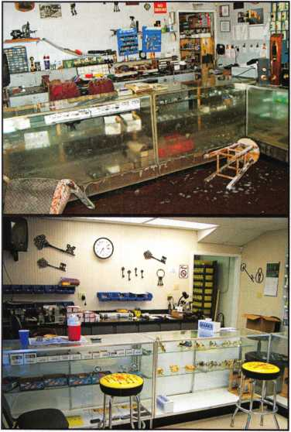

1. What do you like most about your job?

Carl: I love to work with people and converse with people talking about different things. I also like the challenge of rebuilding and old Mortise Lock.

*You must be a current member of The Associated Locksmiths of America in order to be recommended for our Member Spotlight feature. If you would like to be recom­mended or would like to recommend someone else please email our Keynotes Editor, Betty Southerland at [betty@aloa.org](mailto:betty@aloa.org)

Keynotes • February 2007

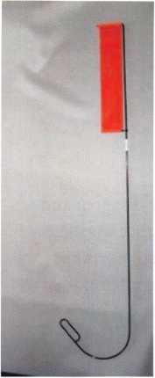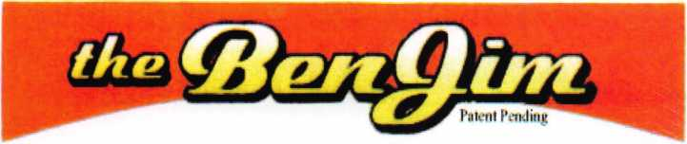

Emergency Door Opening Tool

AS SEEN AT THE 2006 A.L.O.A CONVENTION

All commercial buildings have two things in common:

* Fire code requires that all commercial locks open by a single action.
* The American Disability Act requires free access through doorways,  
  which leaves a gap between the door and the floor.

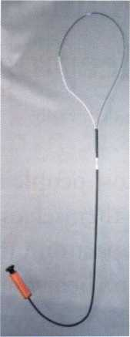

Knoblock Tool

Leverlock Tool

WITH THIS IN MIND WE HAVE DEVELOPED THE TOOLS REQUIRED TO EFFECTIVELY  
OPEN DOORS QUICKLY AND WITHOUT DAMAGE

Designed for interior commercial doors

For knoblocks, the tool is slid under the door with no cords to pull or get tangled.

For leverlocks, a similar tool is used by applying the same method of sliding the tool under the door and pull until the lever retracts.

Both tools are designed to work with very little effort, excessive force is not needed.

Visit our web site at [WWW.THEBEN-JIM.COM](http://WWW.THEBEN-JIM.COM) for more details.

THE BEN-JIM KNOBLOCK TOOL $ 99.00

THE BEN-JIM LEVERLOCK TOOL $ 79.00

SET (one each) $169.00

PLUS SHIPPING & HANDLING

**TO PLACE AN ORDER CALL 1-586-778-1911 OR VISIT US AT [WWW.THEBEN-JIM.COM](http://WWW.THEBEN-JIM.COM)**

MADE IN THE U.S.A BY THE BEN-JIM CORPORATION.

24711 Harper Ave. * St. Clair Shores * MI * 48080 * (Fax) 586-778-0530

Maintain Control:

Keeping Conflict to a Minimum

By: Patti Fralix

Most people do what makes sense to themselves, regardless of the impact on others. When one per­son’s behavior is not understood and/or accepted by the other per­son, conflict ensues. The conflict can be overt or covert.

If this conflict is managed well, which means without negativity and the inappropriate display of anger, results and relationships can be sustained, and even improved. Unfortunately, too often the opposite occurs. It is time to stop the cycles of act/react and find better solutions to differences than often assumed possible. Before focusing on solutions, lets first discuss conflict in more detail.

Covert conflict occurs when people have differences yet do not discuss them openly. There are two types: avoiding and ignoring. Covert conflict creates inter­nal stress and results in feelings such as discomfort and anxiety, which can include physical manifestations, such as ulcers.

Avoiding conflict is similar to “hiding ones head in the sand, thinking (and hoping) that the issue will go away or be resolved on its own. These thoughts are often subconscious. Ignoring is making a conscious decision to not deal with the issue. This decision can be positive or negative, and the difference relates to one’s intention. If the decision to ignore the conflict is a result of “not majoring on the minors,” that can be a positive and mature response. It can also be a result of choosing to “let this one go,” wanting to make sure that this is something that is a problem one should address, such as a negative pattern of behavior.

i

Overt conflict occurs when people openly disagree and choose to confront (address) it with the other person. This occurs as a result of different perspectives, expec­tations, beliefs, values, and sometimes just informa­tion. When one decides to confront an issue with another, that decision should be made with full knowledge of the possible, and even probable, types of responses, of the other person. The most common types of responses are: competitiveness, compromise and negotiation. One should anticipate and prepare for those possibilities, including the appropriate response to each.

Overt conflict is preferable to covert conflict, since it is not possible to resolve covert conflict. Covert con­flict is like an undiagnosed and untreated disease that usually gets worse if left untreated.

Here are just a few ways that companies can help employees prevent and resolve conflicts:

• Utilize personality assessment tools

Utilizing personality assessment tools can help compa­nies make better hiring decisions. One benefit of these tools is that they increase and/or improve under­standing of the different communication styles and how to communicate most effectively with different types of people. Some conflicts can be prevented with this knowledge.

People are usually either a direct or indirect communi­cator. The direct communicator has more “bottom- line” talk. The indirect communicator uses more qualifiers, which often “soften” what the individual is saying. This difference alone can result in misunder­standing and conflict. To a direct communicator, the person that says “it seems that” (a qualifying phrase) can be heard and thought of as “wishy-washy” and not getting to the point. Understanding differences such

**8**

Keynotes • February 2007

**LEXINGTON’S**

**ARE YOU?**

STANLEY

**MARCH 5th thru MARCH 10th, 2007**

**LEXINGTON**

**KENTUCKY**



as these and communicating effectively based on those differences improves productivity and results.

* Create an environment that is welcoming to diversity

One of the reasons for the increase in conflicts is the increase in diversity without an increase in under­standing and acceptance of the differences. Diversity in and of itself is not positive or negative. It becomes positive when the differences create opportunities for individuals, companies, the marketplace, and society as a whole. When those differences create unresolved conflicts between people, the opportunities are usually lost.

* Make sure there is role clarity and common under­standing of responsibilities and deadlines

Too many conflicts occur because managers fail to provide employees with information related to their job responsibilities and the company in general. Who is accountable for what becomes even more important to clarify in an environment of teamwork and project work. While teamwork is becoming more prevalent and necessary, too often teamwork decision making results in a lack of role clarity. Also, with most people having more responsibilities that they can easily man­age, it is imperative that priorities and deadlines be clear to all.

* Commit to conflict management

Discuss conflict on a general level so that employees understand that change and opportunity always involves conflict. Make sure people understand that managing conflict effectively is a company expecta­tion. Treat employees as adults, expecting that they solve their own problems. When an employee com­plains to a manager about another employee, the managers first questions should be, “Have you dis­cussed your concern with [Name of Employee]?” The manager should be a resource in helping employees to manage their own conflicts, functioning as a coach.

* Implement a communication model for handling conflicts

Many problems can be diffused by effective communi­cation. There are three steps that anyone can use to manage conflicts effectively:

1. Focus first on the desired outcome of the interac­tion. This will usually include that the relationship be maintained, and hopefully improved.
2. Ask More Questions/ Make Fewer Statements.

This will improve understanding.

1. Use the dominant communication style of the other person, Direct or Indirect, even if it is not your dominant style.

Yes, the model is simple, but it is not easy. It is much easier to just start talking without thinking of the desired outcome. It is easy to think the desired out­come should be to make ones point clearly. Counter intuitively, when we focus first on understanding the others position, ours is often heard and accepted bet­ter.

Given increased change, ambiguity, and stress, we should expect more conflict, both covert and overt. Understanding different personality styles, communi­cating effectively with different people, and utilizing the three-step communication model are good strate­gies for managing conflict. When conflict is under­stood and managed effectively, results and relation­ships are improved. ■

About the Author:

Patti Fralix, author of the book "How to Thrive in Spite of Mess, Stress and Less," inspires positive change in work, life, and family through speaking, consulting, and coaching. She is founder and president of The Fralix Group, Inc., a leadership excellence firm based in Raleigh, NC. Patti has spent the past 15 years providing practical solutions to audi­ences of all sizes. For more information, please contact her at [pfralix@fralixgroup.com](mailto:pfralix@fralixgroup.com).

**20**

Keynotes • February 2007

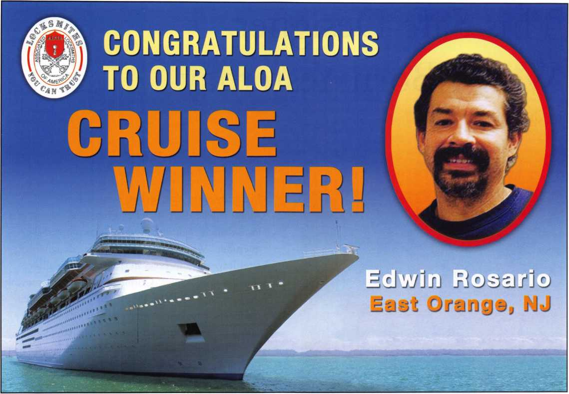

You need it When?

How about now!? :-)

**ClearStar** th **Se«orkV**

Another Special  
Value-added Benefit to your

ALOA Membership! Click here

|  |  |  |
| --- | --- | --- |
|  | 1  [www.clearstar.com](http://www.clearstar.com) / ALOA |  |
|  |  | ) |

This Safe Designer Wasn’t Born Yesterday

by Greg Perry, CML, CPS

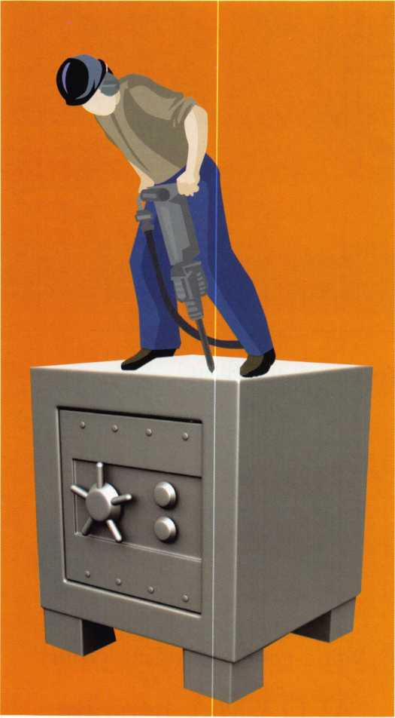

I recently spent close to two hours opening an Amsec square-door safe after a burglary attempt at a local church. Working on this safe prompted the question, “Why do burglars think the designers of safes leave obvious holes in their design to allow them to open a safe?” Criminals think that removing the hinge screws might let them lift the door open. Or maybe knocking off the dial and beating the spindle might get the safe open. They may even knock the handle off in another attempt or perhaps from shear frustration.

Arriving on a Monday afternoon, I found 3 cops, the pastor, and several church members waiting for the afe to be opened. I don’t mind being watched but the crowd pushed my limits for an audience. Since this safe was concealed beneath a counter and under some carpet the church leaders were con­cerned it might be an inside job. They felt that dam­age to the safe might have been done after the con­tents were removed. Closer inspection revealed another clue that the burglary might have been and inside job, or possibly it was committed by someone with inside information. Can you guess what the clue might be? I’ll give you a hint. The safe was probably not opened by the burglar. The dial and handle were knocked off and the hinge screws were removed.

**22**

Keynotes • February 2007

Photo 1, This is the door as it was found

I found 3 cops,  
the pastor, and  
several church  
members waiting  
for the safe  
to be opened.

I don’t mind  
being watched  
but this pushed  
my limits for an  
audience.

Photo 2, All four holes can be seen in this photo.

IN-STOCK...MORE SAFES

***FREE Freight Program***

***(30 States)***

AMSEC FireKing

Eardall hayman

MEILINK y/CTOK

**TURn io**

**WHOLESALE SERVICE**

800-848-9790

Keynotes • February 2007

Hi 4

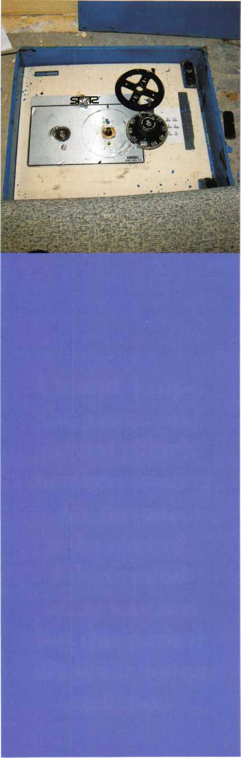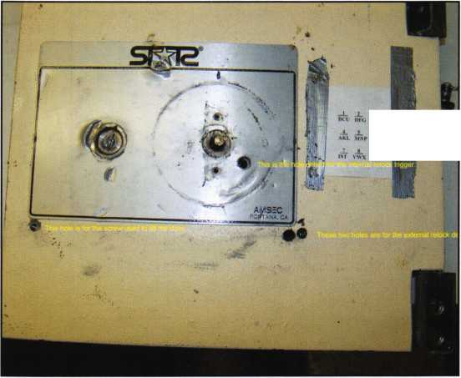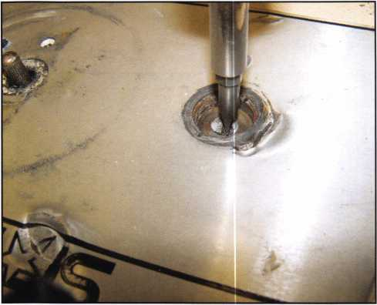

Photo 3, The tip of a screwdriver is in the slot cut in the handle  
shaft.

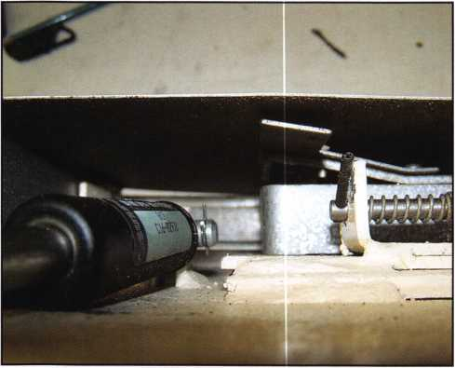

Photo 4, This is a back view, the back sheet metal cover of the safe prevented the lock case cover from breaking completely off.

The spindle moved up and down about 1/2”. My guess was that both the internal and external relocks were fired. The first thing to do was to install an emergency dial. As is usually the case when a safe tech is under pressure, I could not find the emergency dial in my truck. I did the next best thing and carefully reattached the old dial using the combination to align the wheels under the fence.

This was a little difficult to do as the old dial was not held onto the spindle tightly. It required me to keep upward pressure on the spindle to engage the drive pin of the drive cam to the fly of the number-three wheel. Going back to 3 is a dead stop, obviously the internal relock trigger is fired. It was time to either make a hole or continue to punch the spindle into the safe and defi­nitely fire the external relock device. Several tool design­ers have developed tools to align the wheel pack and overcome the internal relock trigger. I chose to drill for the relock, using a piece of bent music wire to pull the end of the relock trigger before turning the dial retract the bolt.

It was then time to turn the end of the spindle handle. The handle was broken below the level of the door sur­face. My choice in this situation was to use a Dremel roto-tool with an abrasive disk to cut a slot in the end of the broken shaft, completing the turn with a screwdriver. The external relock fired. It was time to make another hole. This time, after consulting my library, I miscalcu­lated the drill slightly by using a measurement of 2 3/8” down, 2 1/4” over. In the future I think 2 1/2” over would a better solution. Moving the relock bolt was easy. The problem came when I retracted the boltwork. It would hit the shaft of the tool before the boltwork



Keynotes • February 2007

ACCESS CONTROL SOLUTIONS

Card Readers

Keypads

RF Controls

**V**

The DKS 1838 is a two-door controller that is  
much more than that.

For starters, it easily expands to control up to  
16 doors. Reporting capabilities are included,  
which makes the DKS 1838 ideal for small  
businesses, office buildings, factories,  
industrial sites, apartment complexes,  
condominiums, gated communities...

And more:

* elevator option to control 4 elevators  
  serving up to 64 floors each, with  
  floor access restrictions built-in
* anti-pass back for complete control  
  into, and out of, secured areas
* live transactions - view activity  
  in real time on your computer
* interfaces with card readers,

RF controls, keypads, etc.

* access control for up to  
  3000 users

And that’s not all.

Call today and let us  
show you how DKS  
can simplify your life.

DoorKing telephone entry systems have always been our preferred systems, because they can fit any application we Ve ever run across - small and simple to large and complex.11

Rich Gonzales

Vice President

Mid Atlantic Entry Systems LLC Abingdon MD

120 Glasgow Avenue, Inglewood, CA 90301 U.S.A.

T: 310-645-0023 1-800-826-7493 F: 310-641 -1586 w/M Mi §jf E-mail: [info@doorkinq.com](mailto:info@doorkinq.com) [www.doorking.com](http://www.doorking.com) / ” *

**DOORKING**

Member: AFA, DASMA, IDA, NOMMA, SIA, SSA

for over fifty years

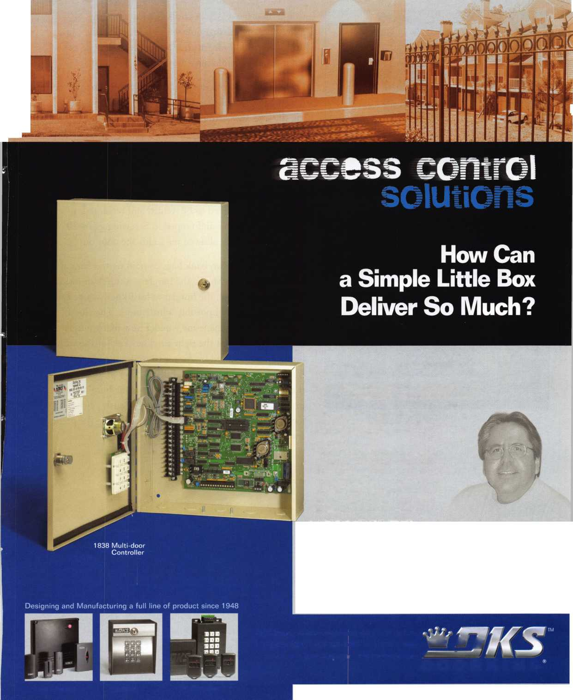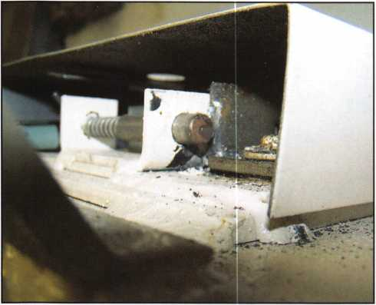

Photo 5, Here is a view of the relock.

Photo 6, A full view of the back of the safe.

would hold the relock in check. I tried to enlarge or move over my existing hole with no luck. Finally I just drilled a second hole for the relock. After a couple of attempts, the handle turned to retract the bolts.

Lifting the door presented another problem. The safe no longer had a handle and the gas piston inside was push­ing the door away from the hinge side. Using screw­drivers (improperly) as prying tools allowed me lift the door a little, but not enough to get it out. In retrospect, I could have reinstalled the hinge screws to give me a little more room. Then, instead of fighting me, the gas piston would have been helpful in lifting the door. Instead, since the door needed to be welded and repainted, I drilled another hole and tapped it. Screwing a 1/4-20 screw into the hole allowed me to lift the door out.

Inside, we found two bank bags containing the Sunday collection money. Maybe the burglary was not an inside job but chances are, the burglar at least knew where the safe was located and possibly a little more. The clue I mentioned earlier made me wonder how many burglars come prepared with the right sized hex key for the socket head-cap screws used by Amsec to secure the hinges? Burglars aren’t apt to carry a full selection of tools with them on a job. My personal thought is the burglar had inside knowledge of the facility but obviously did not have access to the combination. Only catching the perpe­trator will tell for sure.

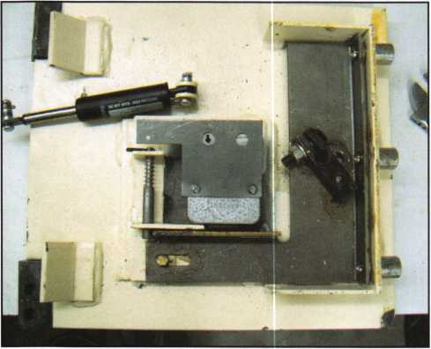

Keynotes • February 2007



Don't miss the ALOA

* . # . #* * *

Opep.Golf Tournament

26, 2007!

Held during the ALOA Convention and

• *

Security Expo, this is a great -event.  
for friends, food anjd.sqpn^dmazj^^S  
ing networking opportOmtiesJitm^^SS  
Register early to .ensure plc^si  
grouping preferences. You'lt  
want to move fast beTore **w£V*V»*?.A*j**

• ..y# ?

reach the 144-player **Cut** off.* **V;*. . .**As always, proceeds from’  
the tournament will benefit  
the ALOA Scholarship **\***

Foundation. Use the **conveKjg^V' 'Jf**tion registration form, found  
online and in the ALOA ‘ **• <**

Convention and Security Expo  
brochure to.save yt>ur spot today!

This year, the popular ALOA Golf Tournament will be held at the area's finest daily-fee golf course, the 18-hole Arnold Palmer-designed championship golf course at Birkdale in

|  |  |
| --- | --- |
|  |  |
|  |  |

Huntersville, NC. Voted the "Best New Golf

Course in North Carolina " and one of the "Top Five Public Courses in the State," this excep­

tional course features facilities that range well beyond the 7,013-yard layout of golf holes.



Our business environment today is a series of ongoing information exchanges between the security professional and existing or poten­tial customers. The quality of dis­cussion between salesperson and customer will have a significant influence on purchases of products and/or services. Understanding this connection is fundamental to improving sales effectiveness.

Business communication between salesperson and customer hinges on two basic components: speaking and listening. Being knowledgeable about your product lines and services and being able to commu­nicate this to your customers is vital to sales success. Listening skills in a sales presentation are essential to success for the security professional.

Top sales professionals listen carefully to explore con­sumers’ needs. They ask questions and listen. A truly great salesperson listens, not to get information to manipulate, but to assist in serving customers. They view themselves as counselors, professionals and problem solvers. Only through effective ques­tioning and listening can they understand the con­sumer’s concerns well enough to offer solutions.

This is particularly true in the security industry.



Keynotes • February 2007

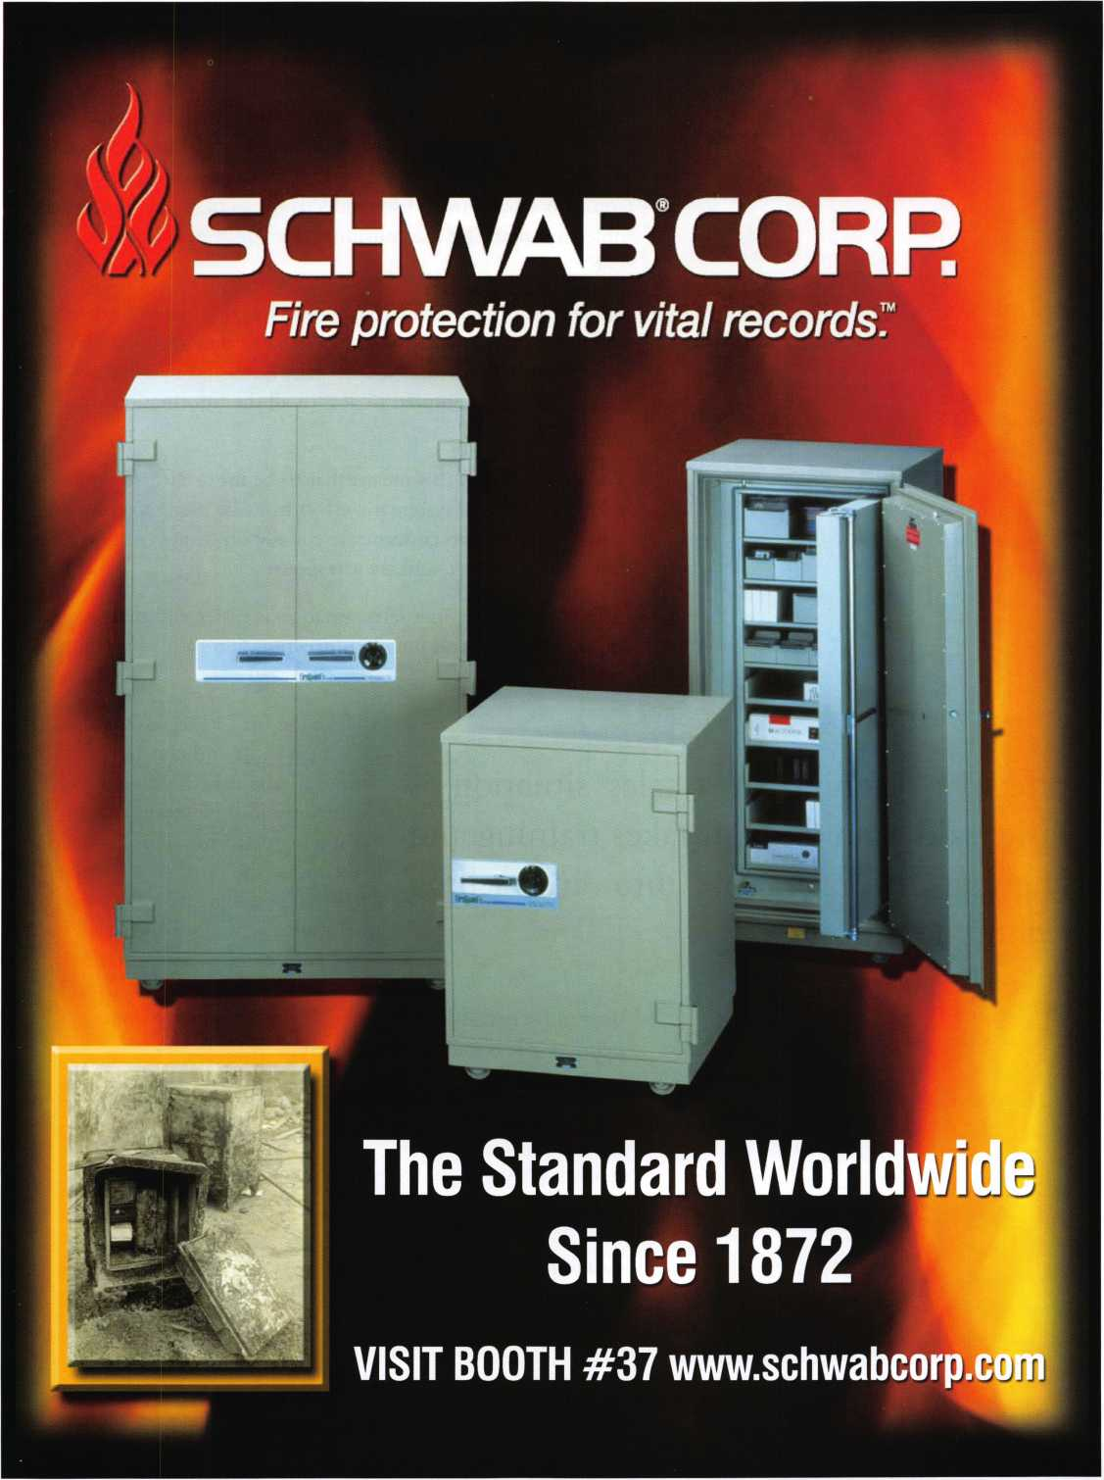

Customers respond positively to sales people who say “Tell me your problems, needs and concerns”.

Often the salesperson is thinking about what they should or will say at the expense of what the customer or potential cus­tomer is actually telling them. The challenge for the salesper­son is to learn how to listen effectively, so that a key point or objection made by the consumer does not result in a lost sale.

Some studies that have been done reveal that when the aver­age person had listened to someone talk, they remembered only about half of what was actually said - no matter how intensely they attempted to absorb all the information com­municated.

For a salesperson, this means that to be most effective in any selling situation a systematic effort must be made to con­sciously attempt to concentrate equally on what is said to a potential customer, and their response.

Effective listening in a sales situation is easier said than done. It takes training and ongoing incorporation into any selling technique process.

Effective listening in easier said than done.

ongoing incorporation technique process.

Make the first 30 seconds count.  
Create a short and concise “com-  
mercial” about yourself, your  
company, and the services your  
company performs. This can help  
to educate the prospect by high-  
lighting problems that you can  
help solve or major benefits you  
and your company can offer. It  
also creates a need for your prod-

ucts and services. This is something that must be done  
before a sale is made. Then listen!

a sales situation is  
It takes training and

into any selling

• Avoid distractions by giving your undivided attention to the customer

* Make good eye contact
* Take notes if appropriate
* Observe and listen hard, listening with your eyes and ears, paying attention to the prospect s body language

Keynotes • February 2007

**WE ARE LISTENING TO YOUR NEEDS!**

ALOA offers you the strength of over 8,000 leading firms & individuals. ALOA is YOUR voice in the industry. ALOA represents the collective interests of the association to the press, government, and the public. ALOA is able to open many doors needed for your success in our ever-changing industry.

CONTACT:

Associated Locksmiths of America 3500 Easy Street Dallas, TX 75247

Phone 800-532-2562 • Fax 214-819-9736 [www.ciloa.org](http://www.ciloa.org)

ft7 J.

' > ^ It ®

**GET READY. CHANGE IS  
AROUND THE CORNER!**

Take a LOOK at some of the new things  
ALOA has planned for YOU in 2007.

ALOA is excited about the new changes in-store  
for everyone in 2007. For this membership cam-  
paign we have listened to the membership and  
are rapidly making changes to suit your needs.

• Don’t miss out as we roll out our new & improved Keynotes  
magazine introducing such interactive features as a  
QStA section exclusively for members.

• More user-friendly ALOA website.

More training & education opportunities.

Better and broader networking possibilities.

• ALOA store with more books plus NEW products

YOUR bottom line.

s, *dfL \\ ■* V



* Keep an open mind (not allowing biases or opinions to interfere with listening)
* Wait for the consumer to finish, then analyze
* Ask questions that encourage dialogue i.e. “Tell me about...”
* Listen for facts and key words
* Zero in on words that are repeated
* Repeat the speakers thoughts
* Let the customer know the message was received by paraphrasing what the consumer has vocalized to you
* Summarize the major points communicated by the consumer
* Develop and rehearse how you are going to strategi­cally respond to common sales prospect purchase objections
* While listening, think about what to say next

Todays successful security professional is ultimately an effective problem solver. With constant practice, a sales professional will quickly realize that how well they listen to consumers is as important as presenting products and services. Whether it is an existing or potential customer, the most successful sales people continuously strive to hone their listening skills to accurately define their customers product and service needs. ■

**ASSA**

**High Security Locks**

**C*alljor tKtst, samples ana a catalog***

**For all your business needs, a complete line of standard and custom products for the Locksmith and Security Profession.**

LOCK £ KEY

* resic
* com □auto

Keystone Techlock

BILL TO: a«o

NAUf

ADDRESS

AOOR6SS

CITY, _

STATE

» _( ) •

**Authorized Provider  
of Logo Apparel**



**Invoices • Labels • Magnets • Metal Safe Plates • Tags • Apparel Security Signs 8c Decals • Complete Marketing Services**

**Professional Business Products 800-355-6322 • [www.pbp2000.com](http://www.pbp2000.com)**

Keynotes • February 2007

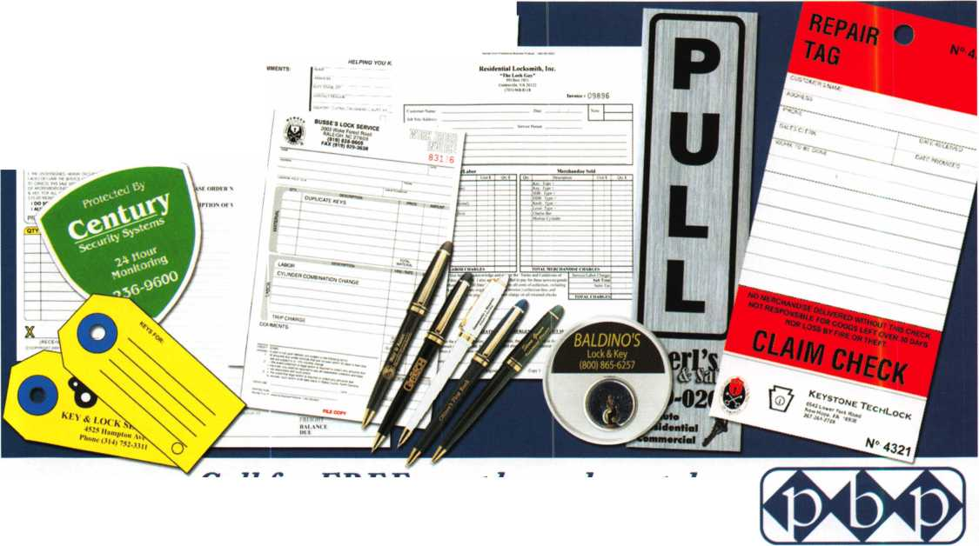

»mr/iJJ£T

T.M.

***OPERATOR SAFETY***

Injuries can be virtually eliminated. Ultra Lift does the lift­ing so that operator effort required to complete a move is minimized. Heavy loads are broken back with ease. The operator stays in control by using a combination of motor power, balance and leverage in every phase of a move.

■_

***REDUCE LABOR COSTS***

Fewer people are required for any move with Ultra Lift. Manpower can be scheduled more productively. Labor savings often pay for the Ultra Lift in one month.

***ELIMINATE DAMAGE***

Loads are broken back, set down and moved under power with maximum leverage and operator control. Gentle handling eliminates bumps, bounces and damage to the load and premises.

***INCREASE PROFITS***

Increased operator safety, reduced labor cost and elimina­tion of damage to the load and premises all contribute to significant increases in profits.

FOR LITERATURE, VIDEO OR ON-SITE DEMONSTRATION, WRITE OR CALL:

ULTRA LIFT supplies the power - so you don't have to. One person can safely and easily handle loads that usually require 2 or 3 people, even up or down stairs. Two people can handle most safes to 1500 pounds. If safety is your concern, ULTRA LIFT is the best move you'll ever make!

ULTRA LIFT CORPORATION

475 STOCKTON AVENUE, UNIT E SAN JOSE, CA 95126 800-346*3057 408-287-9400 FAX 408-297-1199

E-mail: [info@uItralift.com](mailto:info@uItralift.com) [www.ultraFift.com](http://www.ultraFift.com)

U.S. PATENT 4.570.953

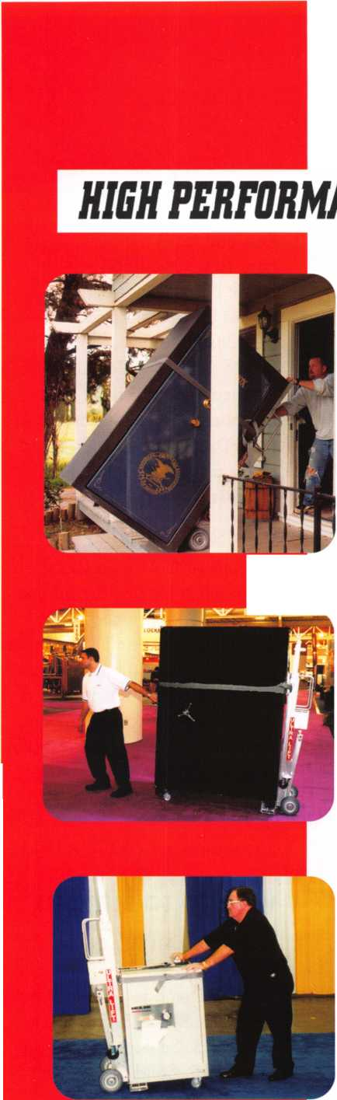

**Classifieds**

EMPLOYMENT

LOCKSMITH WANTED

South King County Locksmith Company (locations in SeaTac and Federal Way) needs inside locksmiths as well as outside technicians. Top benefits pack­age and top pay. Medical,

40IK, paid vacation and plenty of opportunity for advancement. We will supply everything you need (tools, truck, uniform)> Please email or fax resume to: [paulbrandon@lockguys.com](mailto:paulbrandon@lockguys.com) or give me a call at 253-261-3870.

30819 Pacific Highway South Federal Way, WA 98003

EXPERIENCED LOCKSMITH

Established company in Central Virginia is looking for a lock­smith experienced in commer­cial, residential and automotive. Great pay, insurance, retirement plan, paid vacation and holi­days. Needs to be motivated team player. Drug test, back­ground check, good driving record required.

Send resume to:

Albermarle Lock & Safe Co.

513 A Stewart Street

Charlotesville, VA 22902 Attention: Scott Megahan Fax. 434-971-8021 email: [alb.lock@yahoo.com](mailto:alb.lock@yahoo.com)

INVENTORY CONTROLLER WANTED

Inventory Controller wanted at Liberty Lock and Safe in Las Vegas! Inventory experience and hardware knowledge required.

Call James at 702-284-5404 WANTED

Qualified locksmith with at least five years experience. In shop and on the road service. Combination changing, deposit box opening and servicing, installations. Impression, rekey and master key commercial and residential locks. Abloy,

Medeco, Everest, llco Kaba high security locks. Knowledge and experience in opening and serv­icing safes. Reliable with sound team player skills. Applicant must be willing to relocate to Bermuda. Paid vacation, holidays, major medical insur­ance, pension, tools, uniform provided.

Respond to:

Fax: 1-508-366-8864 Email: [barnes-lock@ibl.bm](mailto:barnes-lock@ibl.bm) Barnes Locksmith Service P.O. Box HM 636 Hamilton HM CX, Bermuda Applications who have tried responding to email address in Nov/Dec issues should resend to the above corrected email address.

LOCKSMITH WANTED

A southern California locksmith company is looking for an hon­est, dependable, reliable and experienced locksmith. The com­pany has been in business for 30 years, and is looking for a locksmith to work in both com- mericial and residential. Salary and commission, plus general insurance, paid vacation and 401 K.

Fax resume to: 760-779-1811

WANTED TO BUY/SELL

FOR SALE - ALL ITEMS LIKE NEW!

PRIMUS Demo kit with lock out cylinder - $125. Everest Demo kit - $125. Schlage Finish sam­ples - $15. Solid Oak Mount

Keynotes • February 2007

#44-112 - $50. Single mount composite material - $25. Sold individually or best offer for all. Contact John L. Kish.

Telephone 412-400-5900 Email: [kishjohn@softhome.net](mailto:kishjohn@softhome.net)

BUSINESS FOR SALE

In Brandon, Florida. Two fully equipped service vans, safe chariot, electro-truck, Matrix machine, SDD machine, all other key machines, inventory and stock. Business has been around for 31 years with poten­tial for growth. 200K in sales per year minimum. 160K asking price. Call 813-363-7949 for more details.

SERIOUS INQUIRIES ONLY!

MOBILE LOCKSMITH BUSINESS FOR SALE Owner retiring after 28 years due to health. Many commercial and auto accounts in Chicago and surrounding area. Includes 2003 Dodge Sprinter, ultra code Triax, Bravo key machine, HPC 1200 T-code, RW2 w/tex code Triax, Bravo key machine, HPC 1200 T-code, RW2 w/tex code, NG5, car opening tools and all stock. $145,000 firm. For further information call 1-708-422-4808.

RETIRING EQUIPMENT

Like NEW. Package deal only. 1 High Tech Lockout Kit, 1200 Blitz HPC, 3333 Trace-A-Key, HPC PCH 14, Hand tools, Key Blanks, 16 determinators, pick sets, key pegs, 11 auto tryout key sets, 19K NEW, MAKE OFFER. [Chevieman@aol.com](mailto:Chevieman@aol.com) or call 602-291-3500.

KEY MACHINE FOR SALE

HPC Code Punch Key Machine #HP1200PCH. Like new all cards, cutters and manual, less than 100 keys cut. Asking $850 plus shipping.

Call Mike: 610-446-5793

FOR SALE

20 Schlage A53PD/Tulip/626 NEW - $40 each, 6 Schlage D53 PD/Plymouth/626 NEW - $65 each, 1 Orion KD56 C/E Sidewinder Machine - $1250 OBO, 1 Alboy 6200 Dislock Key Machine. Less than 200 keys cut - $750 OBO, 1 Alboy Ikoz cuts ab 1 Code Machine - $500 OBO, 1 Medeco Key Machine Commercial Keyway - $1700 OBO, 1 Von Duprin 9927 NEW - $250 OBO, Reed Code Books 109 Reed Padlock Code Books, 1, 2, 4 - $100 ALL, Reed & Sons vintage Code Book - Best Offer, Vintage 1938 Auto Code Book - Best Offer, 1

First Master Key Machine - $150, 1 Framon TKM 100- $900 OBO

All prices plus shipping.

Please contact via email at [pdrenderer@bellsouth.net](mailto:pdrenderer@bellsouth.net)

WANTED

New or second hand Alboy Key Cutting machine to cut 9mm key with 1 mm spacing.

Contact Kevin Perry:

sales@easternsuburbslock-

smiths.com.au

MOBILE LOCKSMITH BUSINESS FOR SALE

Due to health. This is a well equipped mobile unit, Chevy Step Van. You can bring this unit to your location so you don't have to relocate. This comes with inventory, tools, Bench setup, HPC Duplicator, Blitz Code machine and more. Asking $15,000. For details call 870-741-0317 or email: [dbknread@alltel.net](mailto:dbknread@alltel.net)

Classified Advertising Policy

Classified advertising space is provided free of charge to ALOA members and for a fee of $2.00 per word, $40.00 minimum for non members. Classified ads may be used to advertise used merchandise and overstocked items for sale, "wanted to buy" items, business opportunities, employment opportunities/positions wanted and the like. Members or non members wishing to advertise services or new merchandise for sale may purchase a "Commercial Classified Ad" for a fee of $4.00 per word with a minimum of $100.00. Each ad will run for two issues. For blind boxes there is a $10.00 charge for members and non members. All ads must be submitted in writing to the Advertising Sales Department via fax at 817-645-7599 or through an email to [adsales@aloa.org](mailto:adsales@aloa.org) by the fifteenth of the month two months prior to issue date. ALOA reserves the right to refuse any classified advertisement that it deems inappropriate according to the stated purpose of the classified advertising section.



Keynotes • February 2007



*.

yi

Distributor

**1 st In Hardware, Inc.**

Phone: Phone: 410-646-9900  
Fax: 410-646-0045  
www. 1 stinhardware.com

**ADEL Fingerprint Technology, LLC**

Phone: 909-595-1222  
Fax: 909-595-1667

**Accredited Lock Supply Co.**

Phone: 800-652-2835  
Fax: 201-865-2435  
[www.acclock.com](http://www.acclock.com)

**American Auto Lock.Com**

Phone: 717-392-6333  
Fax: 717-581-8353  
[www.americanautolock.com](http://www.americanautolock.com)

**Andrews Wholesale Lock Supply**

Phone: 717-272-7422  
Fax: 717-274-8659  
[www.andrewslock.com](http://www.andrewslock.com)

**Boyle & Chase Inc.**

Phone: 800-325-2530  
Fax: 800-205-3500  
[www.boyleandchase.com](http://www.boyleandchase.com)

**Clark Security Products**

Phone: 858-974-6740  
Fax: 858-974-6720  
[www.clarksecurity.com](http://www.clarksecurity.com)

**Cook7s Building Specialties**

Phone: 505-883-5701  
Fax: 505-883-5704

**Dire's Lock & Key Company**

Phone: 303-294-0176  
Fax: 303-294-0198

**Direct Security Supply, Inc.**

Phone: 800-252-5757  
Fax: 800-452-8600

**Discount Key Machines.Com/Busch**

Phone: 800-332-8724  
Fax: 407-363-4666

**Doyle Security Products**

Phone: 800-333-6953  
Fax: 612-521-0166  
[www.doylesecurity.com](http://www.doylesecurity.com)

**Dugmore and Duncan, Inc.**

Phone: 888-384-6673  
Fax: 888-329-3846

**E. L. Reinhardt Co., Inc.**

Phone: 800-328-131 1  
Fax: 651-481-0166  
[www.elreinhardt.com](http://www.elreinhardt.com)

**Ewert Wholesale Hardware**

Phone: 800-451-0200  
Fax: 708-597-0881

**Foley-Belsaw Company**

Phone: 800-821-3452  
Fax: 816-483-5010  
[www.foley-belsaw.com](http://www.foley-belsaw.com)

|  |  |  |
| --- | --- | --- |
| r a <  i ^ v | i s o c i | a t e |
| La | 1 |  |
| it | m e m b e | r s |
| Fried Brothers Inc. | NLS Lock Supply Dba Nevada | ABUS KG |
| Phone: 800-523-2924 | Lock S | Phone: 492-335-634151 |
| Fax: 215-592-1255 | Phone: 702-737-0500 | Fax: 233-563-4130 |
| [www.fbisecurity.com](http://www.fbisecurity.com) | Fax: 702-737-7134 | [www.abus.com](http://www.abus.com) |
| H.L. Flake Co. | Omaha Wholesale Hardware | ABUS Lock Company |
| Phone: 800-231-4105 | Phone: 800-238-4566 | Phone: 800-352-2287 |
| Fax: 713-926-3399 | Fax: 402-444-1664 | Fax: 602-516-9934 |
| [www.hlflake.com](http://www.hlflake.com) | [www.omahawh.com](http://www.omahawh.com) | [www.abus.com](http://www.abus.com) |
| Hans Johnsen Company | Phoenix Safe International LLC | Access Security Products Ltd. |
| Phone: 214-879-1550 | Phone: 765-483-0954 | Phone: 905-337-7874 |
| Fax: 214-879-1530 | Fax: 765-483-0962 | Fax: 905-337-7873 |
| [www.hjc.com](http://www.hjc.com) | [www.phoenixsafeusa.com](http://www.phoenixsafeusa.com) | [www.access-safe.com](http://www.access-safe.com) |
| Hardware Agencies, Ltd. | Positive Identity Solutions | Adams Rite Mfg Company |
| Phone: 416-462-1921 | Phone: 704-663-1175 | Phone: 800-872-3267 |
| Fax: 416-462-1922 | Fax: 704-660-1301 | Fax: 800-232-7329 |
| [www.hardwareagencies.com](http://www.hardwareagencies.com) | [www.pids-usa.com](http://www.pids-usa.com) | [www.adamsrite.com](http://www.adamsrite.com) |
| IDN Incorporated | Security Distributors Inc | Adesco Safe Mfg. Company |
| Phone: 817-421-5470 | Phone: 800-333-6953 | Phone: 800-694-9340 |
| Fax: 817-421-5468 | Fax: 612-524-0166 | Fax: 562-408-6427 |
| [www.idn-inc.com](http://www.idn-inc.com) | Security House | [www.adesco.com](http://www.adesco.com) |
| Instant Hardware Delivery, Inc | Phone: 905-669-5300 | Adrian Steel Company |
| Phone: 800-355-1 107 | Fax: 905-660-6313 | Phone: 800-677-2726 |
| Fax: 800-663-8518 | [www.securityhouselock.com](http://www.securityhouselock.com) | Fax: 517-265-5834 |
| Intermountain Lock & Supply | Southern Lock and Supply Co. | [www.adriansteel.com](http://www.adriansteel.com) |
| Phone: 800-453-5386 | Phone: 727-541-5536 | Advanced Diagnostics USA Inc |
| Fax: 801-485-7205 | Fax: 727-544-8278 | Phone: 650-876-2020 |
| [www.intermountainlock.com](http://www.intermountainlock.com) | [www.southernlock.com](http://www.southernlock.com) | Fax: 650-876-2022 |
| International Electronics, Inc | Stone & Berg Wholesale | [www.autokeys.com](http://www.autokeys.com) |
| Phone: 800-343-9502 | Phone: 800-225-7405 | Alarm Controls Corporation |
| Fax: 617-821-4443 | Fax: 800-535-5625 | Phone: 631-586-4220 |
| Jo Van Distributors | Streetwise Security Products | Fax: 631-586-6500 |
| Phone: 416-288-6306 | Phone: 252-830-5577 | [www.alarmcontrols.com](http://www.alarmcontrols.com) |
| Fax: 416-752-8371 | Fax: 252-830-5542 | All Five Tool Company, Inc. |
| [www.jovanlock.com](http://www.jovanlock.com) | The Locksmith Store Inc. | Phone: 860-583-1691 |
| L V Sales Inc | Phone: 847-364-5111 | Fax: 860-583-4516 |
| Phone: 323-661-4746 | Fax: 847-364-5125 | [www.all5tool.com](http://www.all5tool.com) |
| Fax: 323-661-1314 | [www.locksmithstore.com](http://www.locksmithstore.com) | American Security Products |
| [www.lvsales.com](http://www.lvsales.com) | Timemaster Inc. | Phone: 909-685-9680x2013 |
| i Lockmasters, Inc. | Phone: 859-259-1878 | Fax: 909-685-9685 |
| Phone: 859-885-6041 | Fax: 859-255-0298 | [www.amsecusa.com](http://www.amsecusa.com) |
| Fax: 859-885-7093 | [www.time-master.com](http://www.time-master.com) | BWD Lockcraft |
| [www.lockmasters.com](http://www.lockmasters.com) | Top Notch Distributors, Inc. | Phone: 973-728-3707 |
| Locks Company  Phone: 800-288-0801 | Phone: 800-233-4210  Fax: 800-854-4146 | Fax: 973-728-3731 [www.bwdautomotive.com](http://www.bwdautomotive.com) |
| Fax: 305-949-3619 | [www.topnotch.bz](http://www.topnotch.bz) | Bianchi USA, Inc. |

**Locksmith Ledger International**

Phone: 847-454-2700 Fax: 847-454-2759 [www.lledger.com](http://www.lledger.com)

**McDonald Dash Locksmith Supply**

Phone: 800-238-7541 Fax: 901-366-0005 [www.mcdonalddash.com](http://www.mcdonalddash.com)

**Monaco Lock Co.**

Phone: 800-526-6094 Fax: 800-845-5625 [www.monacolock.com](http://www.monacolock.com)

**Turn 10 Wholesale**

Phone: 800-848-9790 Fax: 800-391-4553

**U.S. Lock Corp.**

Phone: 800-925-5000 Fax: 800-338-5625 [www.uslock.com](http://www.uslock.com)

**Wilson Safe Company**

Phone: 215-492-7100 Fax: 215-492-7104 [www.wilsonsafe.com](http://www.wilsonsafe.com)

Manufacturer

**A & B Safe Corporation**

Phone: 800-253-1267 Fax: 856-863-1208 [www.a-bsafecorp.com](http://www.a-bsafecorp.com)

Phone: 800-891-2118 Fax: 216-803-0202 [www.bianchi](http://www.bianchi) 1770usa.com

**Buddy Products**

Phone: 312-733-6400 Fax: 312-733-8356 [www.buddyproducts.com](http://www.buddyproducts.com)

**CCL Security Products**

Phone: 800-733-8588 Fax: 847-537-1800 [www.cclsecurity.com](http://www.cclsecurity.com)

**CompX Security Products**

Phone: 864-297-6655 Fax: 864-297-9987 [www.compxnet.com](http://www.compxnet.com)

Keynotes • February 2007

associate

members

**D&D Technologies (USA), Inc.**

Phone: 714-677-1300x292 Fax: 714-677-1299 [www.ddtechglobal.com](http://www.ddtechglobal.com)

**DETEX Corp.**

Phone: 800-729-3839 Fax: 830-620-6711 [www.detex.com](http://www.detex.com)

**Don-Jo Manufacturing, Inc.**

Phone: 978-422-3377 Fax: 978-422-3467 [www.don-jo.com](http://www.don-jo.com)

**Door Controls International**

Phone: 800-742-3634 Fax: 800-742-0410 [www.doorcontrols.com](http://www.doorcontrols.com)

**Door Jamb Armor**

Phone: 201-490-5381 Fax: 201-490-5389 [www.djarmor.com](http://www.djarmor.com)

**Doorking Inc.**

Phone: 800-826-7493 Fax: 310-641-1586 [www.doorking.com](http://www.doorking.com)

**Dorma Architectual Hardware**

Phone: 717-336-3881 Fax: 717-336-2106 [www.dorma-usa.com](http://www.dorma-usa.com)

**E-Lock USA**

Phone: 434-589-5913 Fax: 434-589-3738 [www.e-lock-usa.com](http://www.e-lock-usa.com)

**FireKing Security Products**

Phone: 800-457-2424 Fax: 800-896-6606 [www.fkisecuritygroup.com](http://www.fkisecuritygroup.com)

**Framon Manufacturing Company Inc.**

Phone: 989-354-5623 Fax: 989-354-4238 [www.framon.com](http://www.framon.com)

**G-U Hardware Inc.**

Phone: 757-877-9020 Fax: 757-877-9720

[www.g-u.com](http://www.g-u.com)

**HPC, Inc.**

Phone: 847-671-6280 Fax: 847-671-6343 [www.hpcworld.com](http://www.hpcworld.com)

**HY-KO Products Co.**

Phone: 330-467-7446 Fax: 330-467-7442

**Hammerhead Industries, Inc.**

Phone: 805-658-9922 Fax: 805-658-8833 [www.gearkeeper.com](http://www.gearkeeper.com)

**Ingersoll Rand Security Technologies**

Phone: 317-805-5713 Fax: 317-805-5779 [www.schlagelock.com](http://www.schlagelock.com)

**Jackson Corporation**

Phone: 323-269-8111 Fax: 800-888-6855 [www.jacksonexit.com](http://www.jacksonexit.com)

**Jet Hardware Mfg., Co.**

Phone: 718-257-9600 Fax: 718-257-0973 [www.jetkeys.com](http://www.jetkeys.com)

**KABA ILCO Corp.**

Phone: 252-446-3321 Fax: 252-446-4702 [www.kaba-ilco.com](http://www.kaba-ilco.com)

**KEY-BAK/West Coast Chain Mfg.**

Phone: 909-923-7800 Fax: 909-923-0024 [www.keybak.com](http://www.keybak.com)

**Kenstan Lock Company**

Phone: 516-576-9090x315 Fax: 516-576-0100 [www.kenstan.com](http://www.kenstan.com)

**Keri Systems Inc.**

Phone: 408-451-2520 Fax: 408-441-0309 [www.kerisys.com](http://www.kerisys.com)

**Knaack Manufacturing Co.**

Phone: 800-456-7865 Fax: 815-459-9097 www. weatherg ua rd .com

**Kustom Key Inc.**

Phone: 800-537-5397 Fax: 800-235-4728 [www.kustomkey.com](http://www.kustomkey.com)

**LAB Security**

Phone: 800-243-8242 Fax: 860-583-7838 [www.labpins.com](http://www.labpins.com)

**La Gard Inc.**

Phone: 310-325-5670 Fax: 310-325-5615 [www.lagard.com](http://www.lagard.com)

**Lock America, Inc. dba L.A.I. Group**

Phone: 714-373-2993 Fax: 714-373-2998 [www.laigroup.com](http://www.laigroup.com)

**LockPicks.Com/Brockhage Tools**

Phone: 408-437-0505 Fax: 408-516-9642

**Lucky Line Products, Inc.**

Phone: 858-549-6699 Fax: 858-549-0949 [www.luckyline.com](http://www.luckyline.com)

**M.A.G. Manufacturing**

Phone: 714-891-5100 Fax: 714-892-6845 [www.magmanufacturing.com](http://www.magmanufacturing.com)

**MPT Industries, Inc.**

**MUL-T-LOCK USA, Inc.**

Phone: 800-562-3511 Fax: 973-778-4007 [www.mul-t-lockusa.com](http://www.mul-t-lockusa.com)

**Major Mfg, Inc.**

Phone: 714-772-5202 Fax: 714-772-2302 [www.majormfg.com](http://www.majormfg.com)

**Maxcess Card Systems Ltd**

Phone: 800-713-4823 Fax: 650-552-9285

[www.maxcess-card.com](http://www.maxcess-card.com)

**Medeco Security Locks**

Phone: 540-380-5000 Fax: 540-380-5010 [www.medeco.com](http://www.medeco.com)

**Mil-Comm Products Co Inc**

Phone: 201-935-8561 Fax: 201-935-6059

**Promet Safe Inc.**

Phone: 860-436-6246 Fax: 860-436-6876 [www.promet-safe.com](http://www.promet-safe.com)

**Protex Safe Co., LLC**

Phone: 818-610-8030 Fax: 818-610-8004 [www.protexsafe.com](http://www.protexsafe.com)

**ROFU International Corp.**

Phone: 253-922-1828 Fax: 253-922-7272 [www.rofu.com](http://www.rofu.com)

**Rutherford Controls Int'l Co.**

Phone: 519-621-7651

Fax:519-621-7939

[www.rutherfordcontrols.com](http://www.rutherfordcontrols.com)

**STRATTEC Security Corp.**

Phone: 414-247-3333 Fax: 414-247-3564 [www.aftermarket.strattec.com](http://www.aftermarket.strattec.com)

**Sargent & Greenleaf, Inc.**

Phone: 859-885-9411 Fax: 859-885-3063 [www.sargentandgreenleaf.com](http://www.sargentandgreenleaf.com)

**Sargent Manufacturing Co.**

Phone: 800-727-5477 Fax: 888-863-5054 [www.sargentlock.com](http://www.sargentlock.com)

**Schwab Corp.**

Phone: 765-447-9470 Fax: 765-447-8278 [www.schwabcorp.com](http://www.schwabcorp.com)

**Securifort Inc**

Phone: 819-359-2226 Fax: 819-359-2218 [www.securifort.com](http://www.securifort.com)

**Securitron Magnalock Corp.**

Phone: 775-355-5625 Fax: 775-355-5636 [www.securitron.com](http://www.securitron.com)

**Security Door Controls**

Phone: 805-494-0622 Fax: 805-494-8861 [www.sdcsecurity.com](http://www.sdcsecurity.com)

**Security Solutions**

Phone: 405-376-1600 Fax: 405-376-6870 [www.securitysolutions-usa.com](http://www.securitysolutions-usa.com)

**Select Engineered Systems**

Phone: 305-823-5410 Fax: 305-823-5215 [www.selectses.com](http://www.selectses.com)

**Townsteel, Inc.**

Phone: 626-858-5080 Fax: 626-858-3393 [www.townsteel.com](http://www.townsteel.com)

**Trine Access Technology**

Phone: 718-829-2332 Fax: 718-829-6405 [www.trineonline.com](http://www.trineonline.com)

**Videx Inc.**

Phone: 541-758-0521 Fax: 541-752-5285 [www.videx.com](http://www.videx.com)

**WMW Innovation Company**

Phone: 888-474-2341 [www.sure-strike.com](http://www.sure-strike.com)

Service

Organization

**Allstate Insurance Company**

Phone: 847-551-2181 Fax: 847-551-2732 [www.allstate.com](http://www.allstate.com)

**Cardservice Mobile Solutions**

Phone: 561-210-8488 Fax: 561-953-6268 [www.cardservicems.com](http://www.cardservicems.com)

**Cross Country Automotive Services**

Phone: 800-541-2262 Fax: 781-393-0256 [www.argosi.com](http://www.argosi.com)

**HRH Insurance**

Phone: 817-462-3630 Fax: 817-462-3680 [www.hrh.com](http://www.hrh.com)

**Massglass & Door Service**

Phone: 888-742-8837 Fax: 805-497-2255 [www.massglass.com](http://www.massglass.com)

**SalesGenie.Com**

Phone: 402-593-4500 [www.salesgenie.com](http://www.salesgenie.com)

**The Mechanic Group, Inc.**

Phone: 845-735-0700 Fax: 845-735-8383 [www.mechanicgroup.com](http://www.mechanicgroup.com)

**Webster Safe & Lock Co., Inc.**

Phone: 901-332-2911 Fax: 901-332-2878 [www.webstersinc.com](http://www.webstersinc.com)

Keynotes • February 2007

**3**

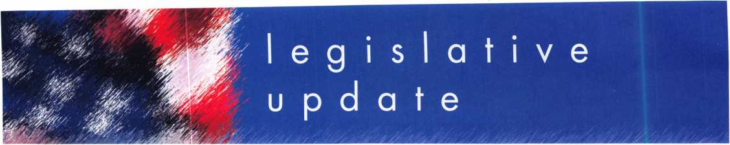

**HOUSE PUSHES MINIMUM WAGE INCREASE, WITHOUT ASSOCIATION HEALTH PLANS**

The House passed a bill Jan. 10 raising the mini­mum wage from $5.15 to $7.25 an hour in three stages over 26 months.

Part of the House leadership's "100 hours" agen­da, the bill (H.R. 2) was moved with no amend­ments. House Republicans had offered a proposal that paired the minimum wage hike with associa­tion health plan (AHPs) legislation and other incentives to help small businesses shoulder increased payroll costs, but House Democrats elected to proceed with a clean minimum wage bill. The bill calls for an increase to $5.85 an hour 60 days after it's signed into law, then $6.55 an hour one year later, and then to $7.25 an hour one year after that.

The Senate is expected to move quickly on its own minimum wage bill, but the author of small business health plan (SBHP) legislation in that chamber, Senate Health, Education, Labor and Pensions ranking member Mike Enzi (R-WY), said

this week that he is not in favor of offering SBHPs as an amendment to the Senate minimum wage bill. There will likely be some "sweeteners" for small businesses added to that bill, however, in order to get the 60 votes needed to end debate. Among the small business tax breaks that could be added to the wage increase is an expansion of Section 179 small business expensing limits. Although the House passed its own bill, House Majority Leader Steny Hoyer (D-MD) said the House may consider accepting the Senate version to avoid a conference committee.

Enzi did vow to continue to push for SBHP legisla­tion this year, even as Senate HELP Chairman Edward Kennedy (D-MA) said this week that Congress should extend Medicare to all Americans in order to provide coverage to the millions of uninsured. Enzi said Jan. 10 he is committed to working toward a bipartisan solu­tion to the nation's health care crisis, and told Congress Daily that "small business pooling power is an important component of any health reform effort."

**NOTEWORTHY: ALOA MODEL LAW**

FWCLA recently completed a thorough review of the ALOA Model Law. After getting input from sev­eral sources and after reviewing existing laws of other states, a suggested model law for Florida was created. This model law is now accessible for review via links at two sites. These are: [www.fwcla.org](http://www.fwcla.org), and [www.serlac.com](http://www.serlac.com).

Links to the model law are available by clicking on the "Hot Topic" button on either home page. Readers are asked to comment on the suggested law, to Richard Formica at [towerkey3@aol.com](mailto:towerkey3@aol.com), 813-601-7940.

Keynotes • February 2007

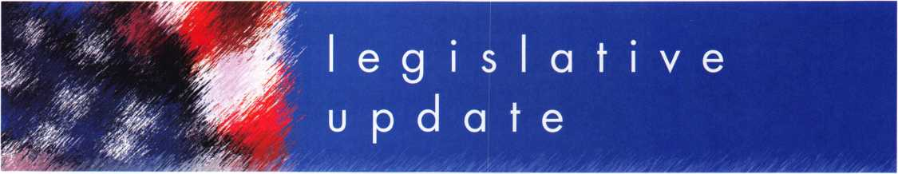

**ALOA LEGISLATIVE REPORT** (As of January 15,2007)

**MONTANA SB 153**

SPONSER: Cocchiarella TITLE: Revise professional and occupational licensing laws ABSTRACT:

Adds Alarm system installer to the current professional licensing board. Adds definition of Security alarm installer to mean, "an indi­vidual who installs, services, or maintains security alarm systems to detect and signal unauthorized intrusion, movement, break-in, or criminal acts and is employed by an electronic security company. Changes definition of "Security alarm system" to mean, "an assembly of equipment and devices or a single device, designed or a portion of a system intended to detect or signal or to both detect and signal unautho­rized intrusion, movement, or crim­inal acts at a location.

STATUS:

• 01/18/2007 (S) Hearing

**NEW JERSEY A2520**

SPONSER: Johnson, G.

TITLE: Concerning electronic secu­rity systems and amending P.L.1962, c.162.

ABSTRACT:

This bill exempts businesses which install, service or maintain access control systems, closed circuit tele­vision systems or intercom systems from licensure by the Board of Examiners of Electrical Contractors. Under current law, locksmiths, burglar alarm, fire alarm and electronic security busi­nesses, and their employees, are licensed and regulated by the board. This bill changes the defini­tion of "electronic security system" contained in the law so that it does not include access control systems, closed circuit television systems or intercom systems. STATUS:

• 02/09/2006 Introduced, Referred to Assembly Regulated Professions and Independent Authorities Committee

**OKLAHOMA SB26 (Same as HB 1054)**

SPONSER: Jolley

TITLE: Professions and occupations and the Alarm and Locksmith Industry Act; deleting an exemp­tion. Effective date ABSTRACT:

Exempts the sale, installation, serv­ice, or repair of alarm systems by individuals licensed pursuant to the Electrical Licensing Act under the Alarm and Locksmith Industry Act.

STATUS:

• 02/05/2007 Will be introduced

**SOUTH CAROLINA Hb3104**

SPONSER: Umphlett TITLE: Locksmith licensing ABSTRACT:

Provide for the licensure of lock­smith agencies, to require employ­ee registration, to require signed work order forms when opening residences, commercial establish­ments, and motor vehicles, and to provide penalties for certain violations.

STATUS:

* 01/09/2007 Referred to Committee on Labor, Commerce and Industry HJ-60

**WASHINGTON HB1001 (Same as SB5038)**

SPONSER: Lovick

TITLE: Combating auto theft.

ABSTRACT:

Commission of a burglary or motor vehicle theft, this act adds the following language, "It shall be prima facie evidence of circum­stances evincing an intent to use for commission of a burglary or motor vehicle related theft for a person to be in possession of mul­tiple vehicle keys or altered vehi­cle keys unless such person is a bona fide locksmith.

STATUS:

* 01/10/2007 Referred to Committee on Public Safety & Emergency Preparedness

**JOIN ALOA'S LEGISLATIVE ACTION NETWORK TODAY!**

As a Legislative Action Network member, you will be "in the know" about the latest legislative happenings in your state. Each member will receive a quarterly newsletter giving them the latest insight to security legislation at the state and federal levels.

It's easy to join! Just send an email to [legislative@aloa.org](mailto:legislative@aloa.org) and put"LAN" and your membership number in the subject line. We'll get you on the network right away!

If you contribute $100 or more to the Legislative Action Fund you become a member of the prestigious Legislative Action Network (LAN) Council. The Council is an important instrument in raising the standards of our profession through the legislative process by making sure that locksmiths have the final say in how our industry will be run. As a Council member, you will receive:

* The quarterly Legislative Action Network Update alerting you to important legislation in your state and around the country (same as LAN members)
* A comprehensive guide to lobbying in your state capital, so you can be the "voice of ALOA" to legislators.
* A lapel pin designating you as a special ALOA LAN Council member
* Recognition in Keynotes magazine.
* Invitation to exclusive functions at the annual ALOA convention for LAN Council members.
* Complimentary Legislative Convention merchandise.

It's simple to join the LAN Council:

* Log into the ALOA Store at <http://www.aloa.org/store>
* Click on Search and type in "Council"
* From there you can join at four different donor levels
* Add this to your basket and checkout!
* Note: if this is the first time you have used the ALOA Store since December 2004, you will need to set up a username and password.

Keynotes • February 2007

**3**

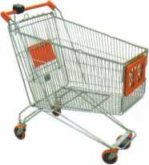

keynotes

Buyer



r*

rv

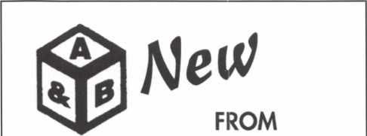

SAFE CORPORATION

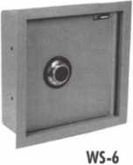

Wall safes in two sizes **4" x6"x!2" Deep**

800-253-1267

114 S. Delsea Drive, Suite 3 856-863-1186

Glassboro, NJ 08066 Fax 856-863-1208

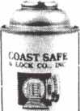

< uawcAN?

‘C»Uf8C>

* »**»«>* **\

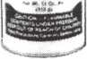

Using a general purpose lubricant? **Be professional!** Use a specially formulated lubricant for the Locksmith and Safe Technician trade. You and your customers will be well pleased. **Guaranteed!**

$48°° + shipping per case.

12-11 oz. cans per case minimum order.  
Order via phone or fax. Credit cards accepted.  
Net 30 W.A.C. or send check with order.

Coast Safe & Lock Co., Inc.

P.O. Box 66257 • Mobile, AL 36606  
(251) 479-5264 • Fax (251) 471 -6967

Facts on Sargent punches.

These new hand operated punches have a few unique features, plus specifications that are worthy enough to mention.

Two models are available, BP201-SGT-L and BP201-SGT-R.

Depending on milling (profile), the blanks are inserted one side or the other. Example; The L series is inserted from the left side and cuts bow to tip. The R series is inserted from the right side and cuts tip to bow, similar to IC products.

If your need is greater for R series, then the BP201-SGT-R will generate them from bow to tip, and the L series tip to bow. Models L or R, each does both. The choice is yours.

SPACES:

.215" to first cut center .156" between cut centers up to  
seven spaces. Factory space tolerance is ± .001".

DEPTHS:

Are in increments of .020", from .330" to .150" for a total  
of 10 depths 1 - 0 (10). Factory tolerance is ± .002".

ANGLE:

Sharpest of most commercial specifications is 78 to 79 degrees.  
Tolerance if any is not specified by Sargent.

FLAT:

Small .051". No tolerance specified.

All of the above are incorporated in each hand punch by;

Locksmithing, Uni. LLC  
Phone: 302-575-0993  
E-mail: [ted@sargentpunch.com](mailto:ted@sargentpunch.com)

Keynotes • February 2007

■ ILIIIJ **I/ill'll**

SCHLAGE

CAL-ROYAL

DOR-O-MATIC

j«umoircbm/x



**MONARCH**

**LCN**

'arrtK.

NATIONAL

**VisalacK**

(fiite#

_ OLYMPUS^

Cbm®CL0CK'INC

TORT

ASSA CbmX

TIMBERLINE

**SARGENT**

DON-JO

**>RROW**

VON DUPRIN

***TOOLS***

*U DEMAND A1*

*A A BfJz*

&m-GOOE **AVENGER BOXER!**

Jft> /SVH

, _ th

***Anniversary***

— innc/

Since 1912



We are celebrating 95 years  
of saving you money!

*H.L. Flake Co*

800-231-4105

SPECIAL NEXT DAY AIR PRICES!

Place your order by 5 PM CST  
& get your order before noon the next day!

HIGH Jet

**LOGMCItAFT|£j**

**BLANCH!**

I LAB IMA TOR

PRQ-LDK

*Jftnn*

iLotmm r<m R M V3> <LSS5SnJSr

***HAT AS*fiac**

**. WKAEA**

o

0

800-231-4105

Shop around and you will see that our  
push button lock prices are the best!

*PL010CKS*

Master Lock

m

*\AM*

**LOCK**

**INDUSTRIAL GRADE SECURITY'**

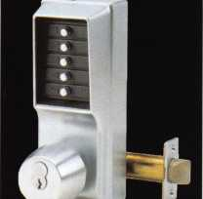

LIST $390

**$199.99**

1011 26D

LIST $655 DL2700* 26D

**ftJ th**

*Anniversary*

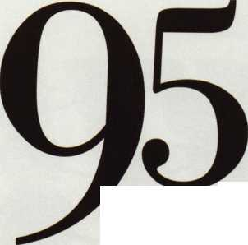

Rejuvenate, Recharge and Reconnect!



Is your local ALOA Chapter or Affiliate taking advantage of all of the benefits available to you? If not, why not?

As Robert Mock, the President of ALOA, recently suggest­ed in his presidential message, “communication is the thread that runs through and binds our professional lives

and our industry.” What better forum to use as your “shar­ing communication program” than your ALOA Chapter or Affiliate. This communication opportunity is just one of the reasons to “kick start” your local chapter or affiliate for 2007.



Keynotes • February 2007

These are just a few of the benefits that ALOA has provided to support your local efforts:

If you need additional information, please do not hesitate to contact your new Chapter and Affiliate Liaison, Ellen McEwen at [ellen@aloa.org](mailto:ellen@aloa.org) or 214-819-9733 extension 203.

Education

ACE class information

Discounts on sponsored classes

Free Chap ter/Affiliate Officer training

• Convention and Trade Shows

ALOA Convention and Security Expo advance information

ALOA endorsement for Affiliate events and shows

Discounts on advertising in Keynotes for Affiliates

An invitation to the “State of the State” roundtable to exchange and share ideas with other Chapters and Affiliates

Communications

Additional copies of Keynotes

Promotion of all chapter activities in Keynotes and aloa.org calendar pages

Legislative Support

Chapter and Affiliate President or designee will receive a Legislative-Action-Network (LAN)-fee- waived membership

New ALOA Slogan

ALOA recently announced a new slogan, “Locksmiths You Can Trust” that can be used  
to accompany the ALOA logo as part of your marketing efforts.

V/,

You can get a digital copy of the logo by contacting the Creative

Services Department ([betty@aloa.org](mailto:betty@aloa.org) or [margarita@aloa.org](mailto:margarita@aloa.org)). You will be  
required to provide your member number to receive the logo.

Shortly you will be receiving a letter explaining our position and one of  
these new logos for your use. Our intention is to create a nationally rec-

ognized symbol which the public can easily identify as representing the  
highest ideals and standards of our profession.

c4 X **

Be on the lookout for this mailing and if you need more they will be available for pur­chase through the ALOA store by this spring.



Keynotes • February 2007



**EASTER  
LOCK i KEY**

325-: 1535 a

*"■*

**USDVA** V **ILLINOIS**

A-1 KEY & LOCK  
24HR SERVICE  
312-555-1234

DUPLICATION

PROHIBITED

**Professional Products for Professional Locksmiths**

**Smart Clone**

**For All Cloneable Keys... Including Ford, Infiniti & Toyota**

**Smart Clone Key Blanks**

**Largest Selection of Groovy Keys... Anywhere**

**Automotive**

**Transponder**

**Keys**

**Precision Key Machines and Cutters**

SC9

KW1+

*Sm)*

**Master Keying and Fine Duplication**

**View Our Complete Line of Professional Locksmith Hardware at**

[www.jetkeys.com](http://www.jetkeys.com)

**JET HARDWARE MANUFACTURING CORP**

**800 Hinsdale Street, Brooklyn NY 11207**

**Jet**

**Exclusives**

**Uni Bow Neuter Bow Personal Line**

